Why we always write PSVM method?

My father sends me to bus stop to pick his friend, but how I identify his friend? My father told me he wear red shirt green pant and yellow cap.

Here JVM always search psvm method to start it’s execution because in JVM psvm method is written in same syntax as we use to start execution.

Can we change PSVM?

Yes, but the customization of JVM is required.

**void** main(String[] args)

**Public**- method can be access from outside the class when we execute the program main method is call by **JVM** which is from outside the class, JVM can be anywhere like in C drive or D drive etc]

**Static**- static method ko use krne k liye uski class ka object banana ki zrurat nahi hai

**With Static**

**package** QA;

**class** second {

**public** **static** **void** main(String[] args) {

System.***out***.println("print 1");

three.*abc*();

}

}l

**package** QA;

**class** three {

**static** **void** abc() {

System.***out***.println("print 2");

}

}

**Without Static**

**package** QA;

**public** **class** second {

**public** **static** **void** main(String[] args) {

System.***out***.println("print 1");

three th = **new** three();

th.abc();

}

}

**package** QA;

**public** **class** three {

**void** abc() {

System.***out***.println("print 2");

}

}

**Void –** Noreturn value

* If a method returns a value then we have to use it in entire program
* In main JVM calling the main method so if we return anything in JVM so what JVM will do with the return type

**Main-** this is the name of method configured inside the JVM [cannot be change]

**STRING AGRS[]-** They are the command line argument, it means whatever the arguments we are passing from command line are called command line arguments

**String**- it’s a predefined class[sab predefined classes ka first letter capital hota hai]

**Args[]-** It is an array variable of string type[its name can be change because it’s a variable]

Can we change the syntax of main method?

**Yes,** though the syntax of main method is very strict but we can do some changes like,

If I found a man on busstop with red shirt green pant and yellow hat but the hat is not on head it is in hand, if I ask my father if hat should be on head or hand then, he is going to slap me, it means we can do some changes in main method

Foe ex:

**public** **static** **void** main(String args[])

1. **static** **public** **void** main(String args[]) //order of modifiers can be change
2. **static** **public** **void** main(String[] args)

**static** **public** **void** main(String []args) // we can declare string in any acceptable form

1. args[] is the name of the array, we can take any name in place of args

**static** **public** **void** main(String ashish[])

1. varargs in java

**public** **static** **void** main(String... args)

**public** **static** **void** main(String ...args)

1. we can declare main with following modifires.

Final

Synchronized

Strictfp

**public** **static** **final** **void** main(String args[])

**public** **static** **synchronized** **void** main(String args[])

**public** **static** **strictfp** **void** main(String args[])

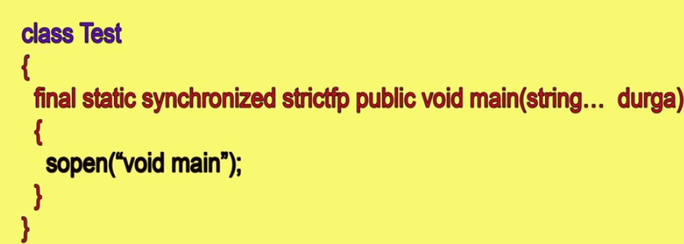

**WE CAN GET ONLY RUNTIME ERROR IF WE DECLARE WRONG SYNTAX OF MAIN METHOD**

# [What is the default scope of a method in Java?](https://stackoverflow.com/questions/714791/what-is-the-default-scope-of-a-method-in-java)

If I type:

void doThis(){

System.out.println("Hello Stackoverflow.");

}

what is the default scope of doThis()?

Public? Protected? Private?

**Ans:** The default scope . All classes in the same package can access the method/field/class.

In cpp we have access specifiers and in java we have access modifiers

**Public :** The public access modifier is specified using the keyword **public**.

* The public access modifier has the **widest scope** among all other access modifiers.
* Classes, methods or data members which are declared as public are **accessible from every where** in the program. There is no restriction on the scope of a public data members.

|  |
| --- |
| //Java program to illustrate  //public modifier  package p1;  public class A  {     public void display()        {            System.out.println("GeeksforGeeks");        }  }  package p2;  import p1.*;  class B  {      public static void main(String args[])        {            A obj = new A;            obj.display();        }  } |

Output:

GeeksforGeeks

**Private:** private methods can be access in same class only.

The private access modifier is specified using the keyword **private**.

* The methods or data members declared as private are accessible only **within the class** in which they are declared.
* Any other **class of same package will not be able to access** these members

|  |
| --- |
| /Java program to illustrate error while  //using class from different package with  //private modifier  package p1;    class A  {     private void display()      {          System.out.println("GeeksforGeeks");      }  }    class B  {     public static void main(String args[])        {            A obj = new A();            //trying to access private method of another class            obj.display();        }  } |

1. Output:
2. error: display() has private access in A
3. obj.display();

**Protected:** The protected access modifier is specified using the keyword **protected**.

* The methods or data members declared as protected are **accessible within same package or sub classes in different package.**

|  |
| --- |
| //Java program to illustrate  //protected modifier  package p1;    //Class A  public class A  {     protected void display()      {          System.out.println("GeeksforGeeks");      }  } |

|  |
| --- |
| //Java program to illustrate  //protected modifier  package p2;  import p1.*; //importing all classes in package p1    //Class B is subclass of A  class B extends A  {     public static void main(String args[])     {  **B obj = new B(); // to be noted   and it is compulsary**         obj.display();     }    } |

Output:

GeeksforGeeks

**Default**: When no access modifier is specified for a class , method or data member – It is said to be having the **default** access modifier by default.

The data members, class or methods which are not declared using any access modifiers i.e. having default access modifier are accessible **only within the same package**.

|  |
| --- |
| //Java program to illustrate default modifier  package p1;    //Class Geeks is having Default access modifier  class Geek  {      void display()         {             System.out.println("Hello World!");         }  } |

|  |
| --- |
| //Java program to illustrate error while  //using class from different package with  //default modifier  package p2;  import p1.*;    //This class is having default access modifier  class GeekNew  {      public static void main(String args[])         {            //accessing class Geek from package p1            Geeks obj = new Geek();              obj.display();         }  } |

Output:

Compile time error

**Strictfp in java?**

* Stands for string floating point, applicable for classes and methods not variables
* Result of floating point arithmetic is differ from platform to platform

Suppose we divide 10.0/3 i.e double/integer, we get

Windows🡪3.33333335

Linux🡪3.33333

Mac🡪3.333333334

If we want platform independent result then we use strictfp modifier.

Class test{

Public strictfp static void main(String args[]){

Syso(10.0/3); //it follow IEEE 754 standard

}

}

**Strictfp class?**

Here we don’t need to define every method as strictfp

Strictfp Class test{

Public void m1(){

Syso(10.0/3); //it follow IEEE 754 standard

}

Public void m2(){

Syso(10.0/3); //it follow IEEE 754 standard

}

Public void m3(){

Syso(10.0/3); //it follow IEEE 754 standard

}

}

Abstract-strictfp combination is illegal at method level, but it is legal at class level

**What is Java?**

Java is a programming language and computing platform first released by Sun Microsystems in 1995.

**Mention some features of Java?**

Some of the features which play an important role in the popularity of java are as follows:

* Simple: Java is easy to learn. Even though Java is based on C++ , it was developed by eliminating poor programming practices of C++.
* Object-Oriented: Java is an object-oriented programming language. Everything in Java is an Object.
* Platform independent: Java is platform-independent. Java is a write once, run anywhere language. Without any modifications, we can use a program on different platforms.
* Secured: Java is well known for its security. It delivers virus-free systems.
* High Performance: Java enables high performance with the use of JIT (Just-In-Time) compilersx
* Multithreaded: Java Multithreaded features allows us to write programs that can perform many tasks simultaneously. The multithreading concept of Java shares a common memory area. It doesn’t occupy memory for each thread.

**Can you compile a Java class successfully without having the "main" method?**

Yes, we can compile, but it won't run. The "main" method works as the startup function for a Java class, and the JVM calls it for the program execution.

**Would a Java program compile/run if we use <static public void> instead of <public static void>?**

Yes, the program will compile and run as usual

**How would you prove that an array is not null but is empty?**

Call the <Print array.length>. It will print 0. That suggests that the array is empty.

If it would null then, it would thrown a NullPointerException on calling the <Print array.length>

**Multithreading in java?**

**In ms word if we typing a document and if I do any spelling mistake so parallely you are typing, at the same time it gives us spelling mistake so it means inside your msword which is your one process we have some small units/sub processes and those sub processes are called thread.**

**Thread: it is the unit of the process [A program/process is a group of threads]**

Every java program has at least one thread called the main thread, the main thread is created by JVM.

**Multithreading** is a Java feature that allows concurrent execution of two or more parts of a program for maximum utilization of CPU. Each part of such program is called a thread. So, threads are light-weight processes within a process.  
  
Threads can be created by using two mechanisms:   
1. extending the Thread class

We create a class that extends the **java.lang.Thread** class. This class overrides the run() method available in the Thread class.

A thread begins its life inside run() method.

call start() method to start the execution of a thread.

**package** QA;

**class** Hi **extends** Thread {

**public** **void** run() {

**for** (**int** i = 1; i <= 5; i++) {

System.***out***.println("Hi");

**try** {

Thread.*sleep*(1000);

} **catch** (InterruptedException e) {

}

}

}

}

**class** Hello **extends** Thread {

**public** **void** run() {

**for** (**int** i = 1; i <= 5; i++) {

System.***out***.println("Hello");

**try** {

Thread.*sleep*(1000);

} **catch** (InterruptedException e) {

}

}

}

}

**public** **class** multithreadingbythread {

**public** **static** **void** main(String args[]) **throws** InterruptedException {

Hi ob1 = **new** Hi();

ob1.start ();

Hello ob2 = **new** Hello();

ob2.start ();

}

}

2. **Implementing the Runnable Interface**

We create a new class which implements java.lang.Runnable interface and override run() method. Then we instantiate a Thread object and call start() method on this object

**class** Hi1 **implements** Runnable {

**public** **void** run() {

**for** (**int** i = 1; i <= 5; i++) {

System.***out***.println("Hi");

**try** {

Thread.*sleep*(1000);

} **catch** (InterruptedException e) {

}

}

}

}

**class** Hello1 **implements** Runnable {

**public** **void** run() {

**for** (**int** i = 1; i <= 5; i++) {

System.***out***.println("Hello");

**try** {

Thread.*sleep*(1000);

} **catch** (InterruptedException e) {

}

}

}

}

**public** **class** multithreadingrunnableinterface {

**public** **static** **void** main(String args[]) **throws** InterruptedException {

Hi1 ob1 = **new** Hi1();

Hello1 ob2 = **new** Hello1();

Thread t1 = **new** Thread(ob1);

t1.start();

Thread.*sleep*(10);

Thread t2 = **new** Thread(ob2);

t2.start();

}

**Explain about join () method?**

**Example:**

|  |
| --- |
| public static void main (String[] args){  Thread t = new Thread ();  t.start ();  t.join ();  }  From the above code, the main thread has started the execution. When it reaches the code  **t.start()** then ‘thread t’ starts the own stack for the execution.  Once code reaches to **t.join()** it means ‘thread t’ completed its task, then main thread ready to  start Its execution.  **class** Hi **extends** Thread {  **public** **void** run() {  **for** (**int** i = 1; i <= 5; i++) {  System.***out***.println("Hi");  **try** {  Thread.*sleep*(1000);  } **catch** (InterruptedException e) {  }  }  }  }  **class** Hello **extends** Thread {  **public** **void** run() {  **for** (**int** i = 1; i <= 5; i++) {  System.***out***.println("Hello");  **try** {  Thread.*sleep*(1000);  } **catch** (InterruptedException e) {  }  }  }  }  **public** **class** multithreadingbythread {  **public** **static** **void** main(String args[]) **throws** InterruptedException {  Hi ob1 = **new** Hi();  ob1.start();  Hello ob2 = **new** Hello();  ob2.start();  ob1.join();  ob2.join();  System.***out***.println(ob2.isAlive());**// isAlive give is true when all tasks of ob2 is finish**  **otherwise it give us false**  System.***out***.println("Bye");  }  What is isAlive?  **isAlive give is true when all tasks of ob2 is finish otherwise it give us false**  **What does the yield method of the Thread class do?**  A yield () method moves the currently running thread to a  runnable state and allows the other threads  for execution.  Suppose we have two threads of same priority [for ex-5] then yield method won’t work.  Now, we have two threads one of priority 5 one is of 4 if we apply yield method now then thread with  Priority 4 will resume until the execution of thread with priority 5 completed.  public static void main (String[] args){  Thread t = new Thread ();  t.start ();  }  public void run(){  Thread.yield();}}  **Set priority of a thread?**  10 is the highest priority and 1 is the lowest  ob2 is execute first for one time as it has highest priority.  Hi ob1 = **new** Hi();  Hello ob2 = **new** Hello();  ob1.setPriority(1);  ob2.setPriority(10);    Output: |
|  |

Hi

Hello

Hi

Hello

Hi

Hello

Hi

Hello

Hi

**Synchronization in Java Multithreading?**

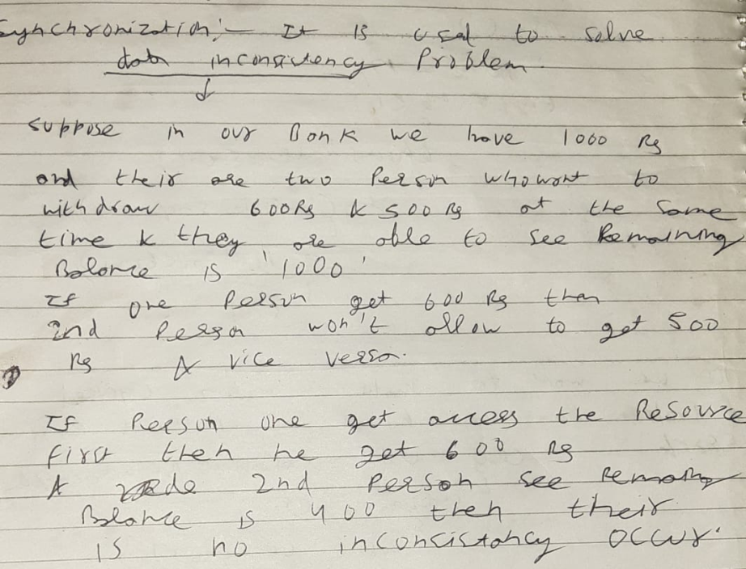

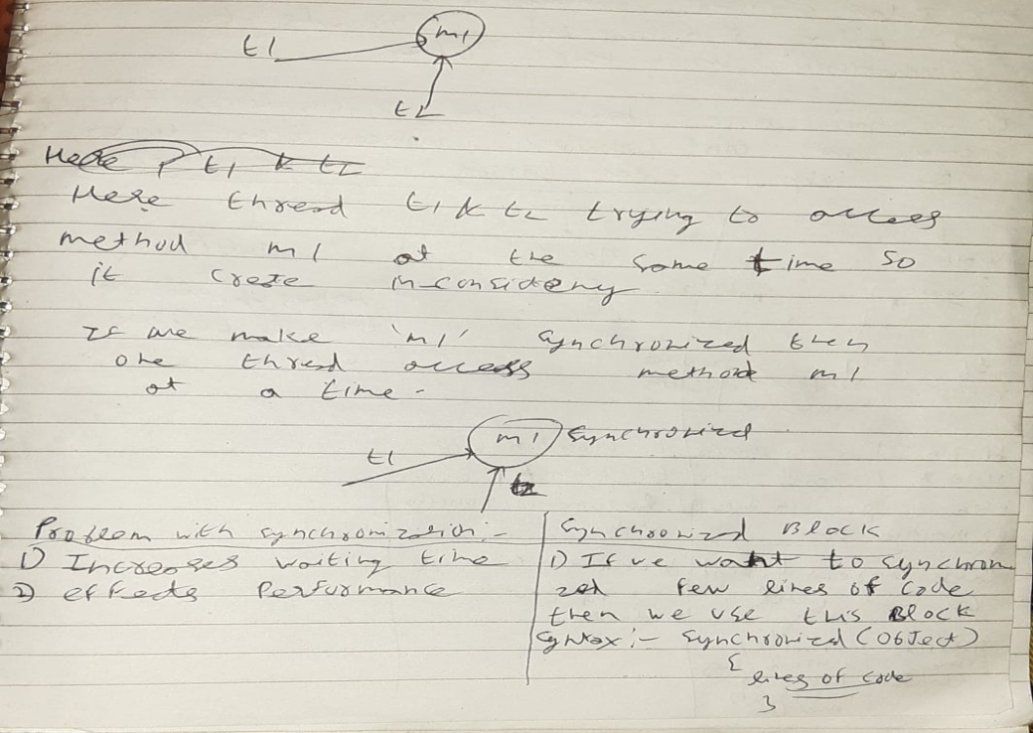

**Inter thread communication in JAVA?**

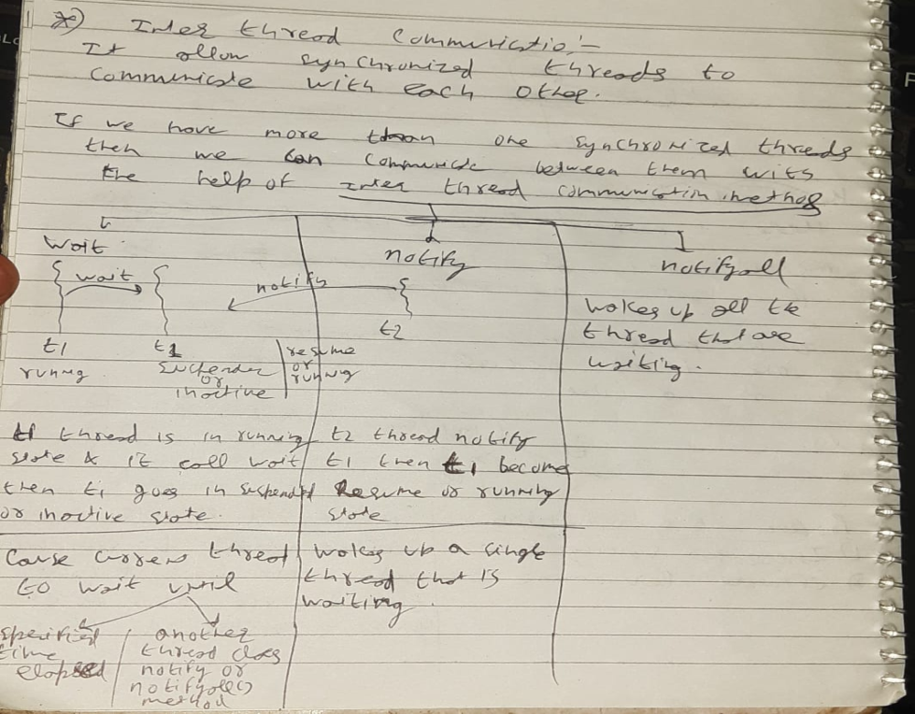

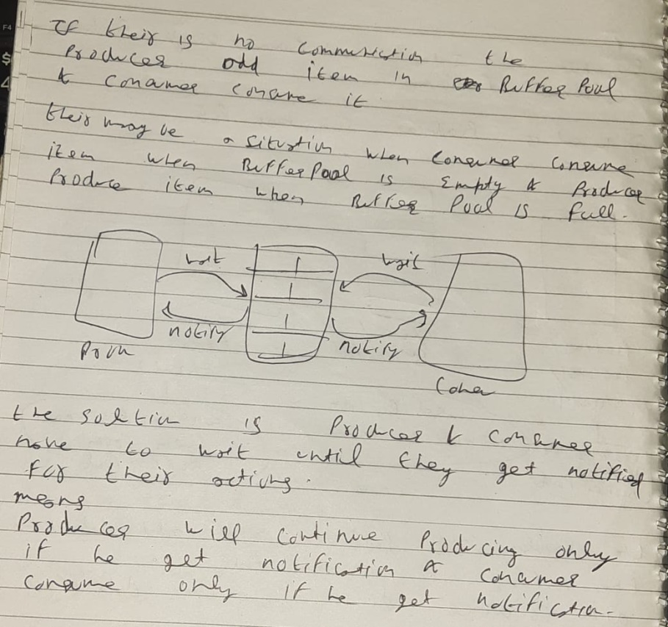

**Life cycle of thread**

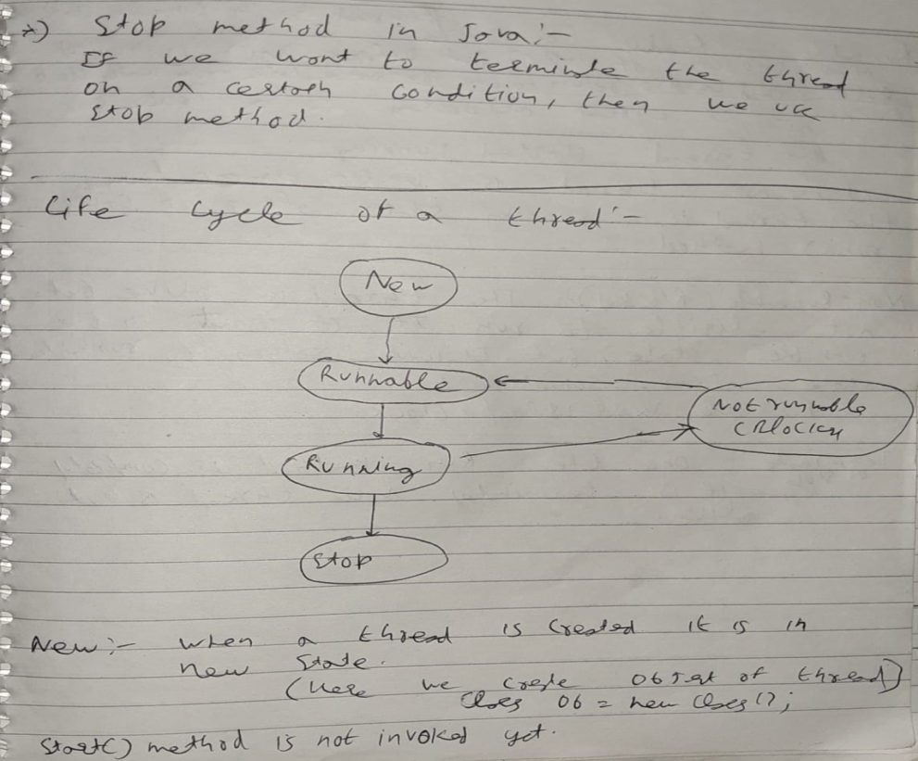

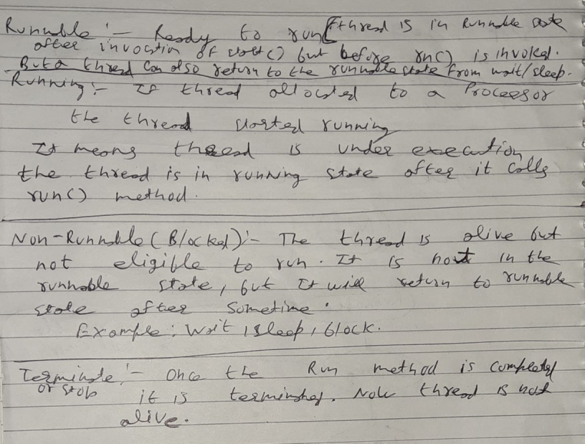

**Explain about wait() method.**

**wait ()** method is used to make the thread to wait inthe waiting pool. Wait () method tells the thread to wait for a given amount of time.

Then the thread will wake up after notify () (or) notify all () method is called.

**How to stop a thread in java? Explain about stop () method in a thread?**

If we want to terminate the thread at a certain condition then, we use stop method.

class definethread extends Thread {

public void run() {

for (int i = 0; i < 5; i++) {

if (i == 2) {

stop();

} else {

System.out.println("A : " + i);

}}}}

public class stopthread {ffi

public static void main(String args[]) {

definethread ob = new definethread();

ob.start();

}

**Explain about sleep () method in a thread?**

**Example:**

**Thread. Sleep (2000)**

So it delays the thread to sleep 2 milliseconds. Sleep () method throws an uninterrupted exception, hence we need to surround the block with try/catch.

|  |
| --- |
| public class ExampleThread implements Runnable{  public static void main (String[] args){  Thread t = new Thread ();  t.start ();  }  public void run(){  try{  Thread.sleep(2000);  }catch(InterruptedException e){  }  }  **When to use the Runnable interface Vs Thread class in Java?**  If we need our class to extend some other classes other than the thread then we can go with the runnable interface because in java we can extend only one class.  If we are not going to extend any class then we can extend the thread class.  **Difference between start() and run() method of thread class.**  Start() method creates a new thread and the code inside the run () method is executed in the new thread.  If we directly called the run() method then a new thread is not created and the currently executing thread will continue to execute the run() method.  **Is there any difference between an argument and a parameter?**  While defining methods, you pass variables which you refer as parameters. And when you call these methods and supply values for the variables, then they are phrased as arguments. |

**What difference you see between pass by reference and pass by value in Java?**

Pass by reference indicates, passing the address itself rather than passing the value. Pass by value means is giving a copy of the value.

**What is the difference between Declaration and Definition in Java?**

**Declaration:** If you just declare a class or method/function or variable without mentioning anything about what that class or method/function or variable looks like is called a declaration in Java.

**Definition:** If you define how a class or method/function or variable is implemented then it is called definition in Java.

When we create an interface or abstract class, we simply declare a method/function but not define it.

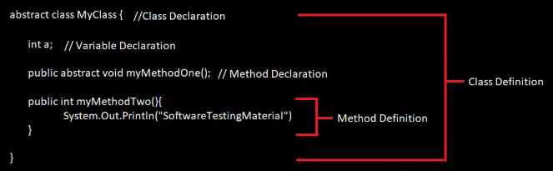

**Abstract method?**

A method without body (no implementation) is known as abstract method. A method must always be declared

**Abstract methods can not declare in non-abstract class**

**Abstract Class?**

Class which have even one abstract method called abstract class

**Abstract class can have abstract/non abstract method**

**package** QA;

**public** **class** abstractclassandmethod {

**public** **static** **void** main(String[] args) {

// maheshphone mp =new maheshphone(); // we Cannot create

// object of abstract class

// mp.call();

sureshphone sp = **new** sureshphone();

sp.call();

sp.move();

sp.cook();

sp.dance();

}

}

**abstract** **class** maheshphone { // Abstract class

**public** **void** call() { // mahesh knows how this phone going to call so he implement this feature

System.***out***.println("Calling....");

}

**public** **abstract** **void** move(); // mahesh dont know how this phone going to move so he dont define this method

// only declares it and it become abstract method

**public** **abstract** **void** dance(); // abstract method

**public** **abstract** **void** cook(); // abstract method

}

**abstract** **class** rameshphone **extends** maheshphone { // Abstract class

**public** **void** move() {

System.***out***.println("moving...");

}

**public** **abstract** **void** dance();

**public** **abstract** **void** cook();

}

**class** sureshphone **extends** rameshphone { // Concrete class

**public** **void** dance() {

System.***out***.println("dancing...");

}

**public** **void** cook() {

System.***out***.println("cooking...");

}

}

**Interface?**

* Like a class, an interface can have methods and variables, but the methods declared in an interface are by default abstract (only method signature, no body).
* Interfaces specify what a class must do and not how. It is the blueprint of the class.
* If a class implements an interface and does not provide method bodies for all functions specified in the interface, then the class must be declared abstract.

**Why do we use interface ?**

* It is used to achieve total abstraction.
* Since java does not support multiple inheritance in case of class, but by using interface it can achieve multiple inheritance.
* It is also used to achieve loose coupling.

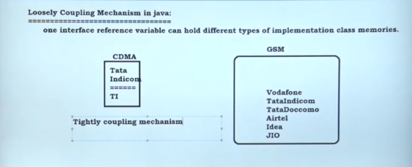

* Interfaces are used to implement abstraction. So the question arises why use interfaces when we have abstract classes?

The reason is, abstract classes may contain non-final variables, whereas variables in interface are final, public and static.

/ A simple interface

interface Player

{

    final int id = 10;

    int move();

}

**package** QA;

**interface** abc {

**void** show(); // it public abstract by default

}

**interface** xyz {

**void** display(); // it public abstract by default

}

**class** Abcimplemet **implements** abc, xyz {

**public** **void** show() {

System.***out***.println("print show");

}

**public** **void** display() {

System.***out***.println("print display");

}

}

**public** **class** Interface {

**public** **static** **void** main(String args[]) {

// abc ob =new abc(); we cannot create object/instantiate a interface

abc ob = **new** Abcimplemet();

ob.show();

xyz ob1 = **new** Abcimplemet();

ob1.display();

}

}

**2nd example:**

**package** QA;

**interface** abc1 {

**void** show(); // it public abstract by default

}

**public** **class** interface1 {

**public** **static** **void** main(String args[]) {

abc1 ob = **new** abc1()

{

**public** **void** show() {

System.***out***.println("hello");

}

};

ob.show();

}

}

Let’s consider the example of vehicles like bicycle, car, bike………, they have common functionalities. So we make an interface and put all these common functionalities. And lets Bicycle, Bike, car ….etc implement all these functionalities in their own class in their own way.

|  |
| --- |
| import java.io.*;    interface Vehicle {        // all are the abstract methods.      void changeGear(int a);      void speedUp(int a);      void applyBrakes(int a);  }    class Bicycle implements Vehicle{        int speed;      int gear;         // to change gear      @Override      public void changeGear(int newGear){            gear = newGear;      }        // to increase speed      @Override      public void speedUp(int increment){            speed = speed + increment;      }        // to decrease speed      @Override      public void applyBrakes(int decrement){            speed = speed - decrement;      }        public void printStates() {           System.out.println("speed: " + speed                + " gear: " + gear);      }  }    class Bike implements Vehicle {        int speed;      int gear;        // to change gear      @Override      public void changeGear(int newGear){            gear = newGear;      }        // to increase speed      @Override      public void speedUp(int increment){            speed = speed + increment;      }        // to decrease speed      @Override      public void applyBrakes(int decrement){            speed = speed - decrement;      }        public void printStates() {           System.out.println("speed: " + speed               + " gear: " + gear);      }    }  class GFG {        public static void main (String[] args) {            // creating an inatance of Bicycle          // doing some operations          Bicycle bicycle = new Bicycle();          bicycle.changeGear(2);          bicycle.speedUp(3);          bicycle.applyBrakes(1);            System.out.println("Bicycle present state :");          bicycle.printStates();            // creating instance of the bike.          Bike bike = new Bike();          bike.changeGear(1);          bike.speedUp(4);          bike.applyBrakes(3);            System.out.println("Bike present state :");          bike.printStates();      }  } |

Output;

Bicycle present state :

speed: 2 gear: 2

Bike present state :

speed: 1 gear: 1

**Tightly Coupling**

One reference variable can have the capability of holding same reference type memory.

**Loosely Coupling**

The same reference variable can have the capability of holding multiple memories

**package** QA;

**interface** I {

**public** **abstract** **void** print();

}

**class** A **implements** I {

**public** **void** print() {

System.***out***.println("Implements A");

}

}

**class** B **implements** I {

**public** **void** print() {

System.***out***.println("Implements B");

}

}

**class** C **implements** I {

**public** **void** print() {

System.***out***.println("Implements C");

}

}

**public** **class** looslycouple {

**public** **static** **void** main(String args[]) {

I ob = **new** A();

ob.print();

ob = **new** B();

ob.print();

ob = **new** C();

ob.print();

}

}

**Interface vs Abstract class**

1. **Type of methods:** Interface can have only abstract methods. Abstract class can have abstract and non-abstract methods. From Java 8, it can have default and static methods also.
2. **Final Variables:** Variables declared in a Java interface are by default final. An abstract class may contain non-final variables.
3. **Type of variables:**Abstract class can have final, non-final, static and non-static variables. Interface has only static and final variables.
4. **Implementation:** Abstract class can provide the implementation of interface. Interface can’t provide the implementation of abstract class.
5. **Inheritance vs Abstraction:** A Java interface can be implemented using keyword “implements” and abstract class can be extended using keyword “extends”.
6. **Multiple implementation:** An interface can extend another Java interface only, an abstract class can extend another Java class and implement multiple Java interfaces.
7. **Accessibility of Data Members:** Members of a Java interface are public by default. A Java abstract class can have class members like private, protected, etc.

|  |
| --- |
| interface In1  {  final int a = 10;      static void display()      {          System.out.println("hello");      }  }    // A class that implements the interface.  class TestClass implements In1  {      // Driver Code      public static void main (String[] args)      {          In1.display();      }  } |

Output :

hello

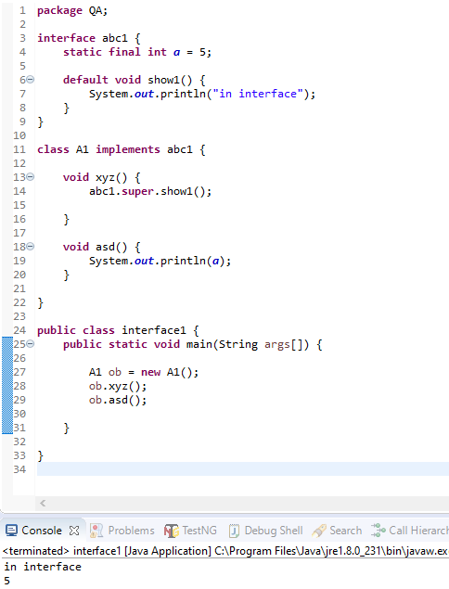

**class** A1 **implements** abc1 {

**void** xyz() {

**show1(); //this will work too //give same input**

}

**void** asd() {

System.***out***.println(***a***);

}

}

package QA;

interface abc {

static void show() {

System.out.println("asada");

}}

interface xyz {

void display(); // it public abstract by default

}

class Abcimplemet implements xyz {

public void display() {

System.out.println("print display");}}

public class Interface {

static public void main(String... ashish) {

Abcimplemet ob1 = new Abcimplemet();

ob1.display();

abc.show();

}

}

**We can declare methods and object in interface.**

**Abstract class**: it contains both abstract methods and concrete methods

We can’t achieve multiple inheritance using abstract class

We can define public, private, protected variables in abstract class

**Interface**: it contains only abstract methods (also we can **define** default and static methods in interface)

We can achieve multiple inheritance using interface

We can’t define public, private, protected variables in interface because It is public by default.

We can achieve 100% abstraction using interface because it doesn’t show any functionality

**interface In1**

**{**

**static void display()**

**{**

**System.out.println("hello");**

**}**

**}**

**// A class that implements the interface.**

**class TestClass implements In1**

**{**

**// Driver Code**

**public static void main (String[] args)**

**{**

**In1.display();**

**}**

**}**

**What is meant by Serialization?**

Converting a file into a byte stream is known as Serialization. The objects in the file are converted to the bytes for security purposes. For this, we need to implement a java.io.Serializable interface. It has no method to define.

**Which methods are used during the Serialization and Deserialization process?**

ObjectOutputStream and ObjectInputStream classes are higher level java.io. package. We will use them with lower level classes FileOutputStream and FileInputStream.

ObjectOutputStream.writeObject**—->**Serialize the object and write the serialized object to a file.

ObjectInputStream.readObject **—>** Reads the file and deserializes the object.

To be serialized, an object must implement the serializable interface. If superclass implements Serializable, then the subclass will automatically be serializable.

# Serialization and Deserialization in Java with Example

Serialization is a mechanism of converting the state of an object into a byte stream. Deserialization is the reverse process where the byte stream is used to recreate the actual Java object in memory.



The byte stream created is platform independent. So, the object serialized on one platform can be deserialized on a different platform.

To make a Java object serializable we implement the **java.io.Serializable** interface.  
The ObjectOutputStream class contains **writeObject()** method for serializing an Object.

The ObjectInputStream class contains **readObject()** method for deserializing an object.

**Points to remember**  
1. If a parent class has implemented Serializable interface then child class doesn’t need to implement it but vice-versa is not true.  
2. Only non-static data members are saved via Serialization process.  
3. Static data members and transient data members are not saved via Serialization process.

# Transient keyword in Java

**transient** is a variables modifier used in [serialization](http://quiz.geeksforgeeks.org/serialization-in-java/). At the time of serialization, if we don’t want to save value of a particular variable in a file, then we use **transient** keyword.

**What is SerialVersionUID?**

Whenever an object is Serialized, the object is stamped with a version ID number for the object class. This ID is called the  SerialVersionUID. This is used during deserialization to verify that the sender and receiver that are compatible with the Serialization.

**What is an Object in Java?**

An object is an instance of a class. Objects have state (variables) and behaviour (methods).

When an object of a class is created, the class is said to be **instantiated**.

Whenever the JVM reads the “new()” keyword then it will create an instance of that class.

Example: A dog is an object of Animal class. The dog has its states such as color, name, breed, and behaviour such as barking, eating, wagging her tail.

**public** **class** MyClass {

// Class name (MyClass) declaration

**public** **static** **void** main(String[] args) {

MyClass obj; //obj is reference here

obj = **new** MyClass(); // Object Creation // we always create obj using new keyword because new keyword is responsible for allocating memory

}

}

# How are Java objects stored in memory?

In Java, all objects are dynamically allocated on Heap.

In Java, when we only declare a variable of a class type, only a reference is created (memory is not allocated for the object). **To allocate memory to an object, we must use new()**. So the object is always allocated memory on heap

Let’s assume that we have a class called Employee in Java. This is how you would create a reference of the Employee class:

*Create a reference*  
**Employee e;**

Now if you wanted to create an instance or object of the Employee class, you would do so:

*Create an reference and an object*  
**Employee e = new Employee ();**

Objects is created with the help of new keyword

**Heap memory and stack memory?**

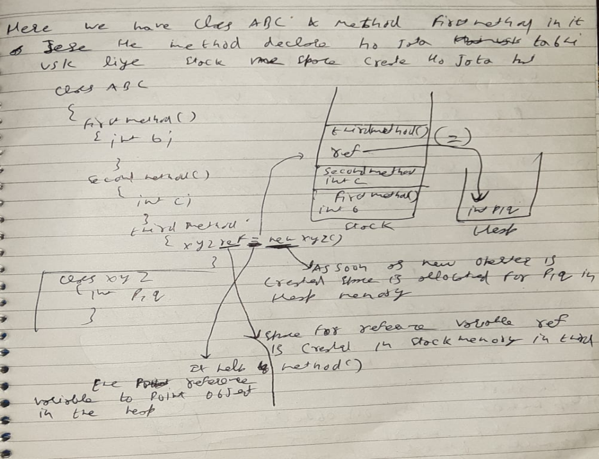

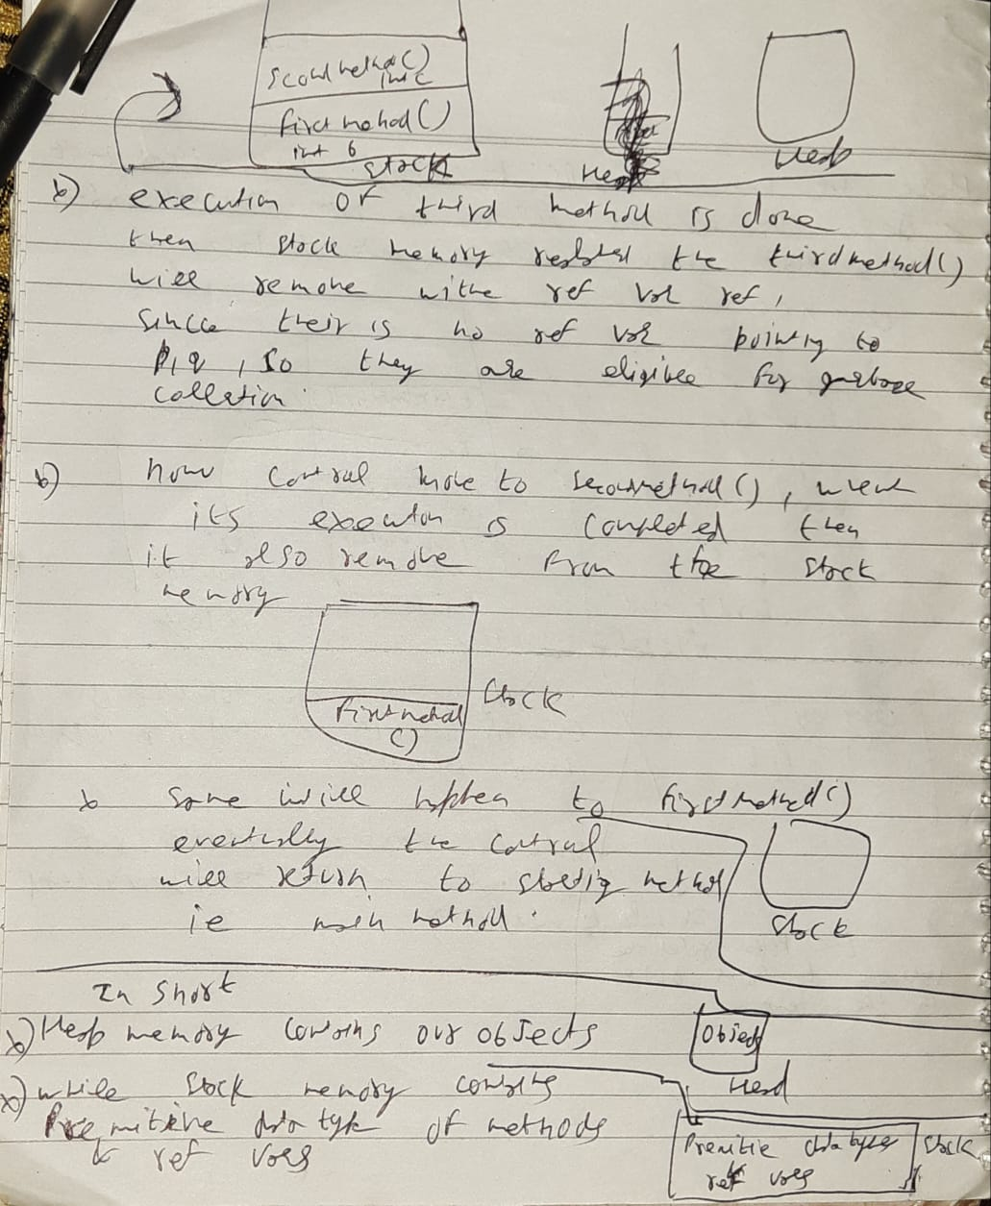

# Different ways to create objects in Java?

# ****Using new Keyword** :** Using new keyword is the most basic way to create an object. This is the most common way to create an object in java. Almost 99% of objects are created in this way. By using this method we can call any constructor we want to call (no argument or parameterized constructors).

/ Java program to illustrate creation of Object

// using new keyword

public class NewKeywordExample

{

    String name = "GeeksForGeeks";

    public static void main(String[] args)

    {

        // Here we are creating Object of

        // NewKeywordExample using new keyword

        NewKeywordExample obj = new NewKeywordExample();

        System.out.println(obj.name);

    }

}

# ****Using****[New Instance](https://www.geeksforgeeks.org/new-operator-vs-newinstance-method-java/)**: This method is belongs to a class called ‘class’ which resides in a java.lang package(java.lang.class) and inside the class ‘class’ there is a method called ‘new instance’ which help us to create a object in java**

# ****Using newInstance() method of Constructor class:**** This is similar to the newInstance() method of a class. There is one newInstance () method in the ****java.lang.reflect.Constructor**** class which we can use to create objects.

# **When we call**Class ‘class’ new instance method it internally call Constructor class new instance method to create an object.

# Class ‘class’ new instance method vs Constructor class new instance method.

# Class ‘class’ new instance method:

# It is always look for a constructor which is public and default.

# Throws all the exception.

**Constructor class new instance method:**

1. It invoke any parameterize constructor, and private constructor
2. It wraps all exceptions in one exception i.e **invocation target exception**.

**Using**[**clone() method**](https://www.geeksforgeeks.org/clone-method-in-java-2/)**:** Whenever clone() is called on any object, the JVM actually creates a new object and copies all content of the previous object into it. Creating an object using the clone method does not invoke any constructor.  
To use clone() method on an object we need to implement **Cloneable** and define the clone() method in it.

**Using**[**deserialization**](https://www.geeksforgeeks.org/serialization-in-java/)**:** Whenever we serialize and then deserialize an object, JVM creates a separate object. In **deserialization**, JVM doesn’t use any constructor to create the object.  
To deserialize an object we need to implement the Serializable interface in the class.

We can say that object creation is directly handle by ‘readObject’ method in deserialization

We learn that constructor is not getting call in **clone** and **deserialization**.

**What is a Class in Java?**

A class can be defined as a collection of objects. It is the blueprint or template that describes the state and behavior of an object.

public class MyClass{ //Class name (MyClass) declaration

int a = 9; // Variable declaration

int b = 99;

public void myMethod(){ //Method (myMethod) declaration

int sum=a+b;

}

}

**What are the OOPs concepts?**

OOPS Stands for Object-Oriented Programming System. It includes

* [INHERITANCE](https://www.softwaretestingmaterial.com/oops-concept-in-automation-framework/#INHERITANCE)
* [ENCAPSULATION](https://www.softwaretestingmaterial.com/oops-concept-in-automation-framework/#ENCAPSULATION)
* [ABSTRACTION](https://www.softwaretestingmaterial.com/oops-concept-in-automation-framework/#ABSTRACTION)
* [POLYMORPHISM](https://www.softwaretestingmaterial.com/oops-concept-in-automation-framework/#POLYMORPHISM)
* [METHOD OVERLOADING](https://www.softwaretestingmaterial.com/oops-concept-in-automation-framework/#METHOD-OVERLOADING)
* [METHOD OVERRIDING](https://www.softwaretestingmaterial.com/oops-concept-in-automation-framework/#METHOD-OVERRIDING)
* [INTERFACE](https://www.softwaretestingmaterial.com/oops-concept-in-automation-framework/#INTERFACE)

**Inheritance:**

It is the mechanism in java by which one class is allows inheriting the features (fields and methods) of another class.

Important terminology:

* Super Class: The class whose features are inherited is known as super class(or a base class or a parent class).
* Sub Class: The class that inherits the other class is known as sub class (or a derived class, extended class, or child class). The subclass can add its own fields and methods in addition to the superclass fields and methods.
* Reusability: Inheritance supports the concept of “reusability”, i.e. when we want to create a new class and there is already a class that includes some of the code that we want, we can derive our new class from the existing class. By doing this, we are reusing the fields and methods of the existing class.

**Types of Inheritance in Java**

**Single Inheritance :**In single inheritance, subclasses inherit the features of one superclass

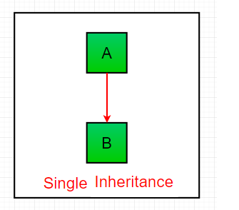

**Multilevel Inheritance :**

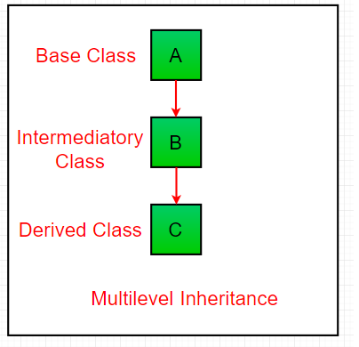

**A is a super/base class which is inherited by B and B is inherited by C.**

**Hierarchical Inheritance**

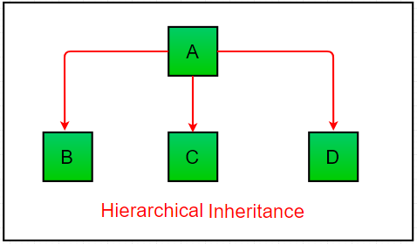

Here, A is a super class

[**Multiple Inheritance**](https://www.geeksforgeeks.org/java-and-multiple-inheritance/)**(Through Interfaces) :**

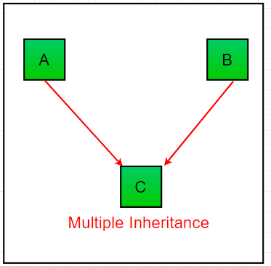

**Why java not support multiple inheritance:**

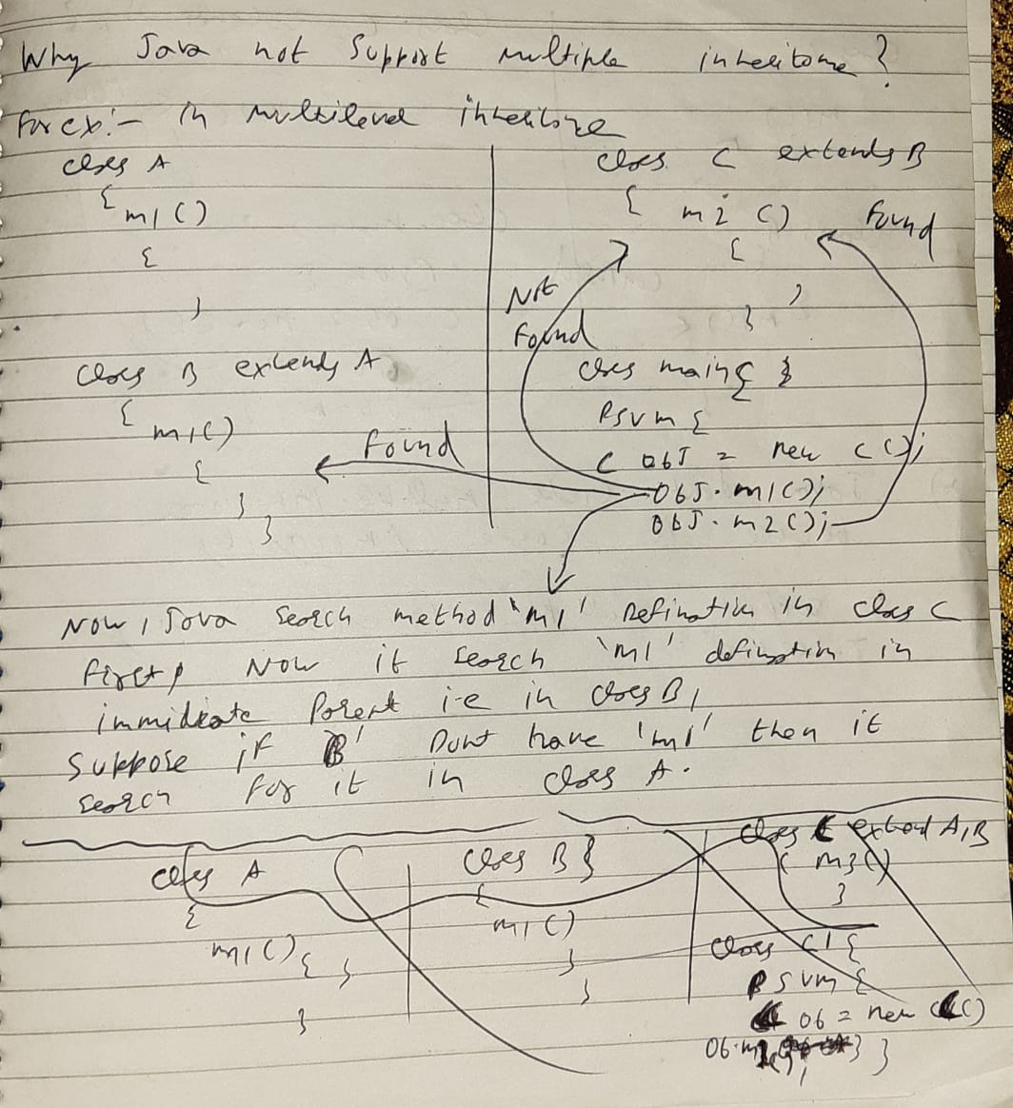

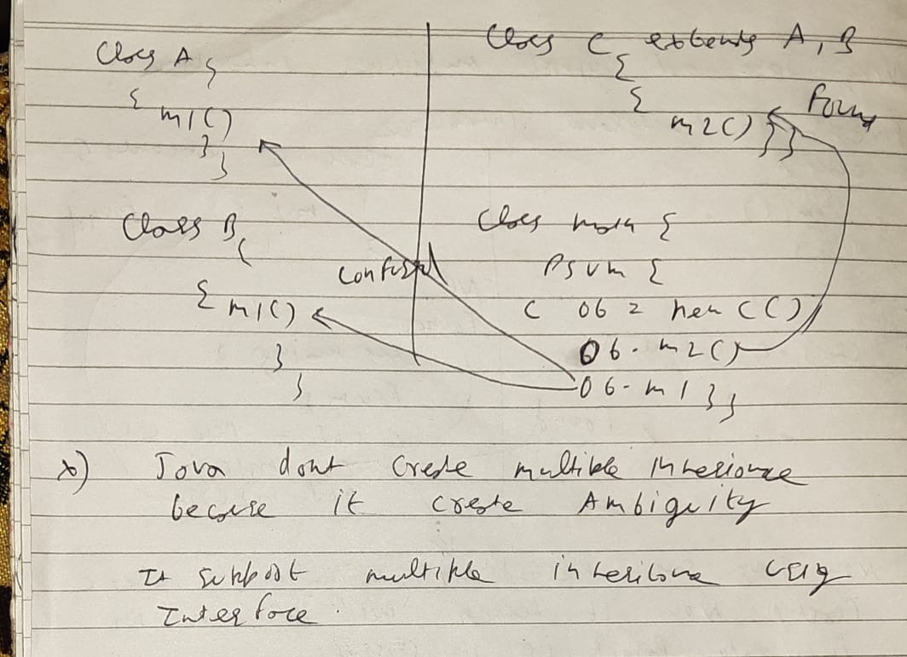

**Why java support multiple inheritance using interface?**

**package** QA;

**Interface** abc {

**void** show(); // it public abstract by default

**int** ***i*** = 10;

}

**interface** xyz {

**void** show(); // it public abstract by default

**int** ***i1*** = 20;

}

**class** Abcimplemet **implements** abc, xyz {

**public** **void** show() {

System.***out***.println("print show : " + abc.***i***);

System.***out***.println("print show : " + xyz.***i1***);

}

}

**public** **class** Interface {

**public** **static** **void** main(String args[]) {

// abc ob =new abc(); we cannot create object/instantiate a interface

Abcimplemet ob = **new** Abcimplemet();

ob.show();

}

}

**Hybrid Inheritance(Through Interfaces) :**It is a mix of two or more of the above types of inheritance. Since java doesn’t support multiple inheritance with classes, the hybrid inheritance is also not possible with classes. In java, we can achieve hybrid inheritance only through [Interfaces](http://quiz.geeksforgeeks.org/interfaces-in-java/).

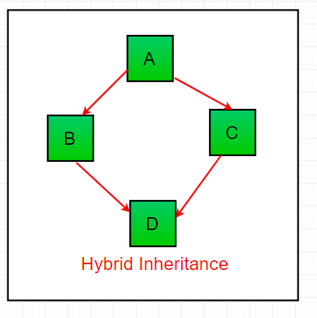

[**Encapsulation in Java**](https://www.geeksforgeeks.org/encapsulation-in-java/)**?**

Encapsulation is a mechanism of wrapping the data(Variables) and code acting on the data(methods) together in a single unit

Steps to achieve encapsulation:

* 1. Declare the variables of a class as private.
  2. Provide public getter and setter methods to modify and view the variables value.

**Setter: help to set the value of variable**

**Getter: help to get the value of variable**

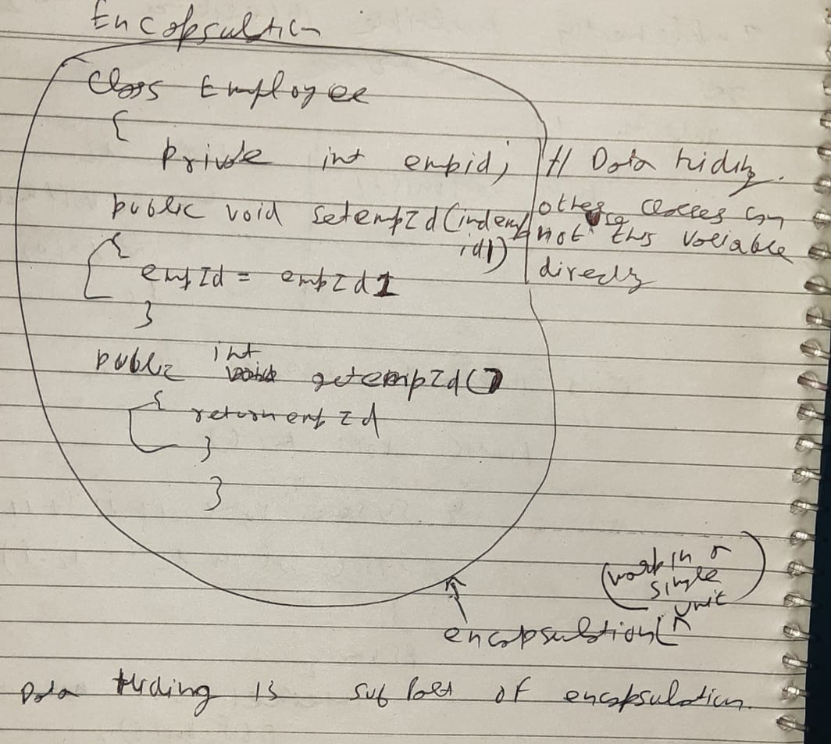

**package** oops;

**import** QA.private_;

**class** setvals {

**private** **int** empID;

**public** **void** setEmpID(**int** empID) {

**this**.empID = empID;

}

**public** **int** getEmpID() {

**return** empID;

}

}

**public** **class** encapsulation_ {

**public** **static** **void** main(String args[]) {

setvals obj = **new** setvals();

obj.setEmpID(10);

System.***out***.println("Employee id is : "+obj.getEmpID());

}

}

**Why encapsulation**

1. **To maintain code that is change frequently by keeping that in one place.**
2. **Help to achieve data hiding that make our code more secure.**

# Abstraction in Java:

# 9

# 

**Encapsulation vs Data Abstraction**

1. [Encapsulation](http://contribute.geeksforgeeks.org/encapsulation-in-java/) is data hiding(information hiding) while Abstraction is detail hiding(implementation hiding).
2. While encapsulation groups together data and methods that act upon the data, data abstraction deals with exposing the interface to the user and hiding the details of implementation.

**Polymorphism in java:**

‘Poly’ means many ‘morphism’ means form

Types of polymorphism:

1. Compile time polymorphism or static polymorphism: It is achieve by method overloading.

Compile time polymorphism is handle by compiler

1. Run time polymorphism or dynamic polymorphism: It is achieve by method overriding.

Run time polymorphism is handle by JVM

**Method Overloading/static poly/compile time poly:** Method is said to be overloaded when many method in a class have a same name but different signature/parameters

**package** QA;

**public** **class** overloading {

**public** **static** **void** main(String agrs[]) {

one ob = **new** one();

ob.m1();

ob.m1(12, 14);

ob.m1(9, 19, 15);

}

}

**class** one {

**void** m1() {

System.***out***.println("No Parameters");

}

**void** m1(**int** i, **int** j) {

System.***out***.println("Two Parameters : " + (i + j));

}

**void** m1(**int** i, **int** j, **int** k) {

System.***out***.println("Three Parameters : " + (i + j + k));

}

}

**It can overload using same number of parameters with different return type**

**void** abc() {

System.***out***.println("in abc");

}

**void** abc(**int** a) {

System.***out***.println("print int");

}

**void** abc(**double** a) {

System.***out***.println("print double");

}

**public** **static** **void** main(String args[]) {

sum ob = **new** sum();

ob.abc();

ob.abc(-1);

ob.abc(2.3);

}

**Method Overriding:**

**Child class method will override the parent class method**

When a method in a subclass has the same name, same parameters or signature, then the method in the subclass is said to override the method in the super-class.

**Overriding method can have different return type but this new type should be,**

* **A Non-Primitive.**
* **A Subclass of what base class’s overridden method is returning i.e. co-variant Return Type(for ex: superclass have return type object and sub class have return type String).**

Lets see an example,

**class** animal {

**public** Object tail() {

System.***out***.println("I hava two legs");

**return** **null**;

}

}

**class** dog **extends** animal {

**public** Object tail() {

**super**.tail(); // it help to call the parent class method declaration even if it is overriden

System.***out***.println("I hava four legs");

**return** **null**;

}

}

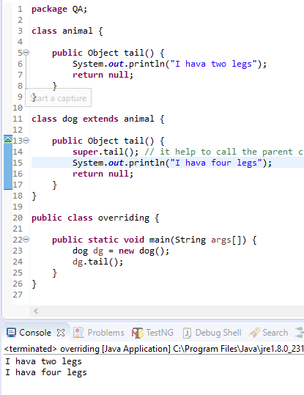

**What is Binding?**

**Linking between method call and method body**

**Difference between static binding and dynamic binding?**

1. Static binding is also known as early binding whereas dynamic binding is also known as late binding.  
   2. Determining the type of an object at compile time is Static binding whereas determining the type of an object at run time is dynamic binding  
   3. Java uses static binding for overloaded methods and dynamic binding for overridden methods.

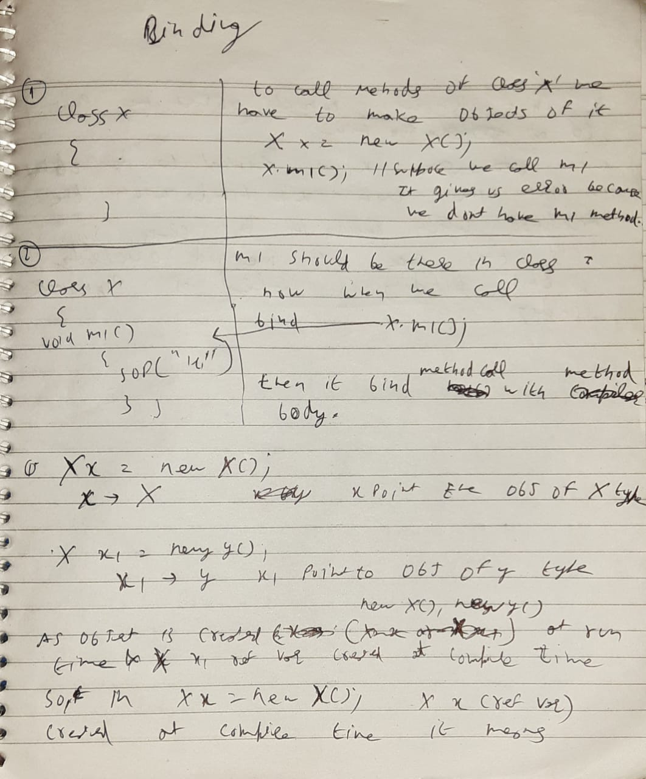

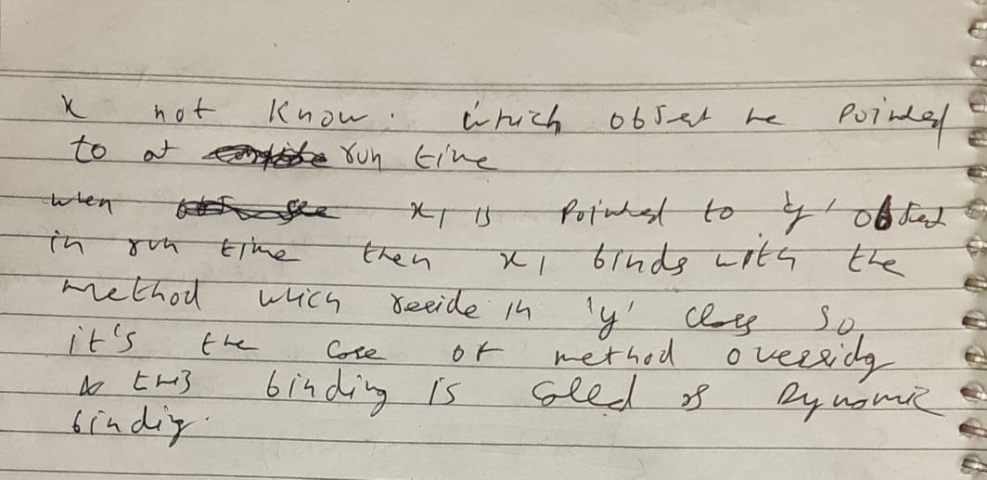

**What is Constructor in Java?**

**Constructor has same name as class name**

**Constructors never return anything, so no return type required in constructor**

**Constructor is public by default**

**When we call an object it automatically call a constructor[A obj =new A() , it will call a constructor of class A]**

**It is used to allocate memory**

**It is a member method[every class has a constructor even if we don’t mention it]**

**Class A{**

**Int I;**

**Float f;**

**A()[default constructor we don’t define it, it come by default]**

**}**

There are two type of constructor in Java:

**No-argument/default constructor:**A constructor that has no parameter is known as default constructor.

**package** QA;

**public** **class** constructor {

**public** **static** **void** main(String args[]) {

callconstructor obj = **new** callconstructor();

System.***out***.println("int default : "+obj.i);

System.***out***.println("string default : "+obj.j);

}

}

**class** callconstructor {

**int** i;

String j;

callconstructor() {

System.***out***.println("in non param conast");

}

}

**Parameterized Constructor:**A constructor that has parameters is known as parameterized constructor.

**package** QA;

**public** **class** constructoroverloading {

**public** **static** **void** main(String args[]) {

constructr obj = **new** constructr(2);

}

}

**class** constructr {

**public** constructr(**int** i) {

System.***out***.println("value of param const "+i);

}

}

**Copy Constructor ?**

A copy constructor in a Java class is a [constructor](https://www.baeldung.com/java-constructors) that**creates an object using another object of the same Java class**.

* To create a copy constructor, we can first declare a constructor that takes an object of the same type as a parameter:

**package** QA;

**class** copyconstructor {

**public** **static** **void** main(String args[]) {

copyme ob = **new** copyme(21, 2);

**new** copyme(ob);

}

}

**class** copyme {

**int** age, roll;

copyme(**int** a, **int** r) {

age = a;

roll = r;

System.***out***.println("age is : " + age + " roll no is : " + roll);

}

copyme(copyme c) {

age = c.age;

roll = c.roll;

System.***out***.println("below is in copy const++++");

System.***out***.println("age is : " + age + " roll no is : " + roll);

}

}

Suppose we have a object and we want to change it’s value its called mutation

**Why string is immutable?**

We change the value of reference (which store in stack memory) but we are not changing actual value (which stores in string pool) that’s what makes string immutable.

**Immutable string :** Increase the Performance of the system

**String** is non-primitive data type

Non-primitive are those whose size are not fix for ex: String, arrays

String is the sequence of characters of array of characters

String is a class which extends object class because object class is the parent of all the classes

**Str/str1= reference**

**Navin = object**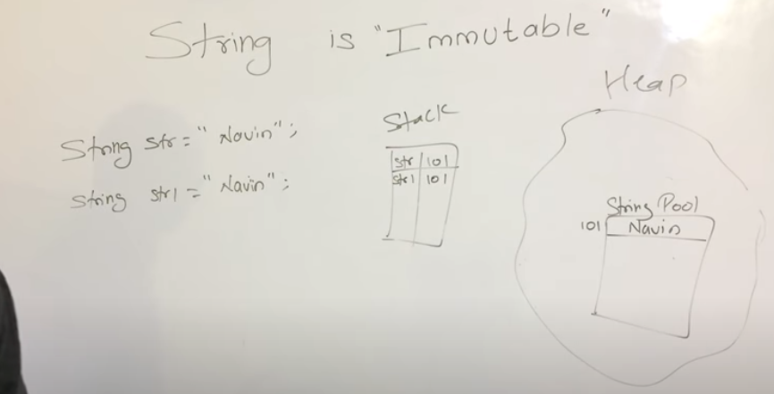

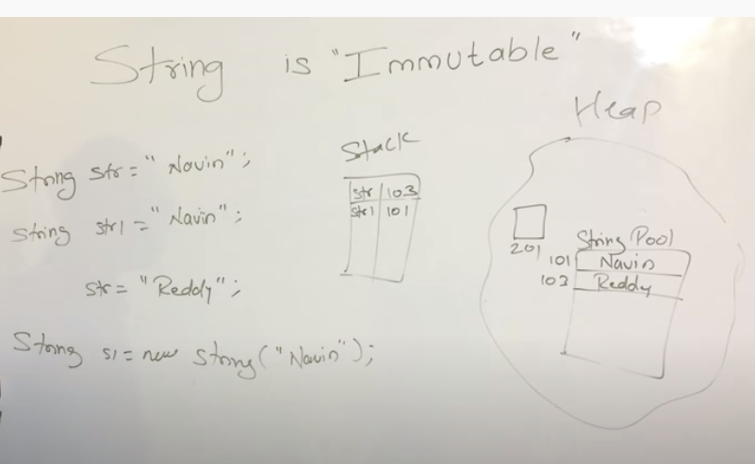

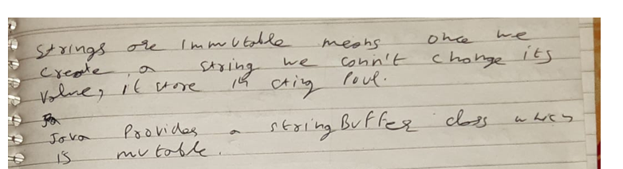

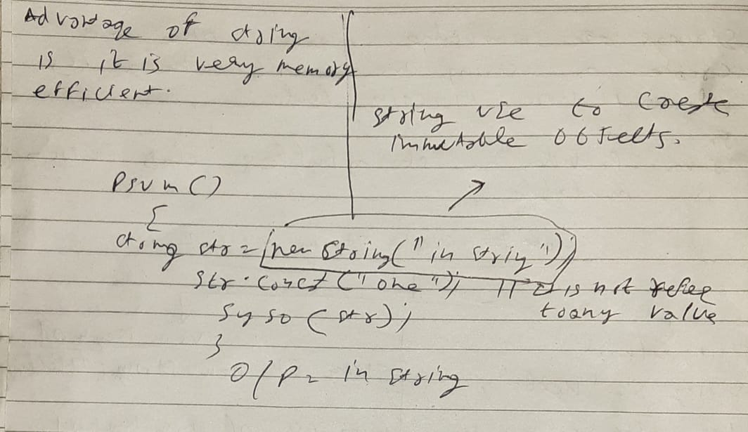

**StringBuffer:**

* Here string values are stored in a stack. If the values are changed then the new value replaces the older value.

**Example:**

String Buffer name =”book”;

[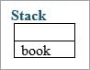](https://cdn.softwaretestinghelp.com/wp-content/qa/uploads/2017/10/Stack.jpg)

Once the name value has been changed to “pen” then the “book” is erased in the stack.

[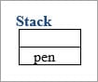](https://cdn.softwaretestinghelp.com/wp-content/qa/uploads/2017/10/Stack1.jpg)

* StringBuffer is synchronized i.e. thread safe. It means two threads can't call the methods of StringBuffer simultaneously.

synchronized  or thread safe means suppose we have two threads t1 and t2 if thread t1 is call any method then t2 will not call any method and if t2 call any method then t1 not call any method.

It means if t1 call then t2 have to wait and vice versa

**package** QA;

**public** **class** Immutable {

**public** **static** **void** main(String args[]) {

String str = **new** String("in string");

str.concat("one");

System.***out***.println(str);

StringBuffer strbfr = **new** StringBuffer("in string");

strbfr.append(" Buffer");

System.***out***.println(strbfr);

}

}

O/P:

in string

in string Buffer

**String:** String variables are stored in a “constant string pool”. Once the string reference changes the old value that exists in the “constant string pool”, it cannot be erased.

**Example:**

String name = “book”;

**Constant string pool**

[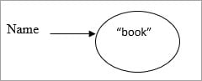](https://cdn.softwaretestinghelp.com/wp-content/qa/uploads/2017/10/Constant-string-pool.jpg).

If the name-value has changed from “book” to “pen”.

**Constant string pool**

[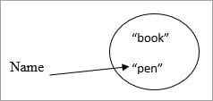](https://cdn.softwaretestinghelp.com/wp-content/qa/uploads/2017/10/Constant-string-pools.jpg)

Then the older value retains in the constant string pool.

**StringBuilder**

StringBuilder is non-synchronized i.e. not thread safe. It means two threads can call the methods of StringBuilder simultaneously.

non-synchronized or not thread safe means suppose we have two threads t1 and t2 both threads can be call method at one time i.e non-synchronized

**package** QA;

**public** **class** Immutable {

**public** **static** **void** main(String args[]) {

StringBuilder builder = **new** StringBuilder("hello");

builder.append("java");

System.***out***.println(builder);

}

}

**StringBufferr and StringBuilder both provide mutable objects but the diff is StringBufferr synchronized  or thread safe where as** **StringBuilder is non-synchronized i.e. not thread safe.**

**What is Local Variable, Instance Variable and Static Variable/ Class variables?**

**Local Variable: It will store in Stack area**  
A local variable is a variable that we declare inside a Method. A method will often store its temporary state in local variables.

**Instance Variable (Non-static): It will store in Heap area**

An instance variable is a variable that is declared inside a Class but outside a Method. We don’t declare this variable as Static because these variables are non-static variables.

**Static Variable: It will store in Method area**

Class variables are variables declared within a class, outside any method, with the static keyword

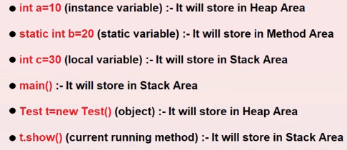

**We can access static variables without creating an Object of a class**

**package** QA;

**public** **class** variables {

**final** **static** **int** ***staticVar*** = 100; // static variable

**int** instanceVar = 200; // instance variable

**public** **static** **void** main(String [] args){

**int** localVar = 300; // local variable

// We can access static variables without creating an Object of a class

System.***out***.println("Value of a Static Variable is "+***staticVar***);

// We cannot access instance variables without creating an Object of a class

//System.out.println("Value of a Instance Variable is "+instanceVar);

// Local variables are limited to this method only

System.***out***.println("Value of a Local Variable is "+localVar);

// Creating an object of VariablesLocalInstanceClass

variables var = **new** variables();

System.***out***.println("Value of a Instance Variable is "+var.instanceVar);

//Updating the value of localVar

localVar = 301;

System.***out***.println("Updated value of a Local Variable is "+localVar);

//Updating the value of instanceVar using the object of VariableLocalInstanceClass

var.instanceVar = 201;

System.***out***.println("Updated value of a Instance Variable is "+var.instanceVar);

/*We can modify the static variable by creating an instance of a class

but to avoid this we can set final keyword

I have added final keyword to the static variable...

If you uncomment the below two statements, you can see an error

If you remove final keyword of static variable staticVar then you wont face any error*/

/*var.staticVar = 101;

System.out.println("Updated value of a Static Variable is "+staticVar);*/

}

}

**argument-vs-parameter-in-java**

1. parameter used in function/method definition.
2. arguments used in function/method call.

package com.stackoverflow.works;

public class ArithmeticOperations {

public static int add(int x, int y) { //x, y are parameters here

return x + y;

}

public static void main(String[] args) {

int x = 10;

int y = 20;

int sum = add(x, y); //x, y are arguments here

System.out.println("SUM IS: " +sum);

}

}

**Enhance for loop/ for each loop in java ?**

**package** QA;

**public** **class** enhanceforloop {

**public** **static** **void** main(String args[]) {

**int** d[][] = {

{ 1, 2, 3, 4 },

{ 5, 6, 7 },

{ 8, 9, 10, 11 },

{ 8, 9 } };

**for** (**int** i = 0; i < d.length; i++) {

**for** (**int** j = 0; j < d[i].length; j++) {

System.***out***.print(d[i][j] + " ");

}

System.***out***.println();

}

//############################################

**for** (**int** k[] : d) { // k store the value of d

**for** (**int** f : k) { // f store the value of k

System.***out***.print(f + " ");

}

System.***out***.println();

}

//############################################

**int** l[]= {1,2,3,4,5,6};

**for** (**int** m :l) {

System.***out***.print(m);

}

}

}

**Arraylist in java?**

**In simple arrays we have to provide size of the array and size of array in those cases are fixed and its hard to change the size of those arrays**

**Java provide a library called util and in util library there is a keyword called array list and this arraylist help us to use and maintain dynamic arrays, so we can increase, decrease its size**

| **Array** | **ArrayList** |
| --- | --- |
| Array is static | ArrayList is dynamic |
| Size of the array should be given at the time of array declaration. We cannot change the size of array after creating it | Size of the array may not be required. It changes the size dynamically. Capacity of Array List increases automatically whenever we add elements to an Array List |
| Arrays are multidimensional | ArrayList is always single dimension |

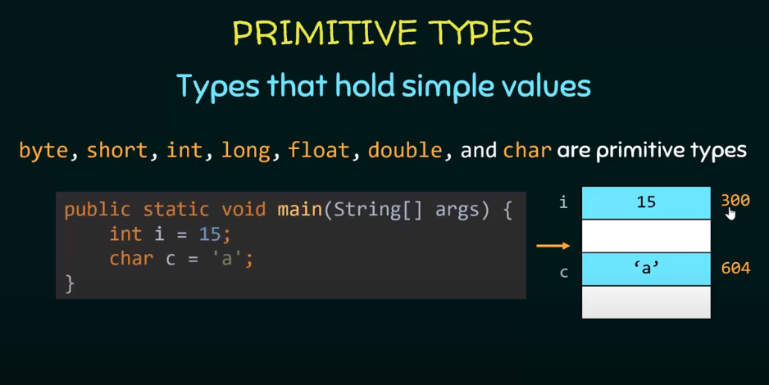

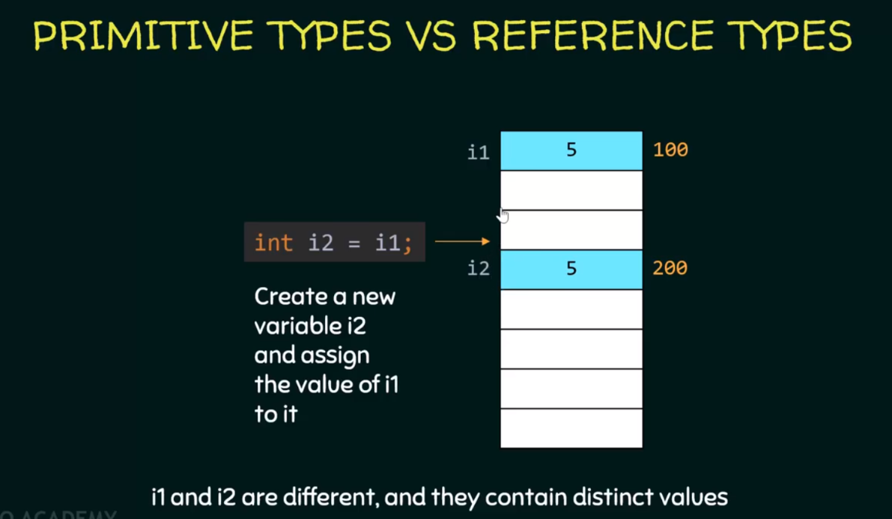

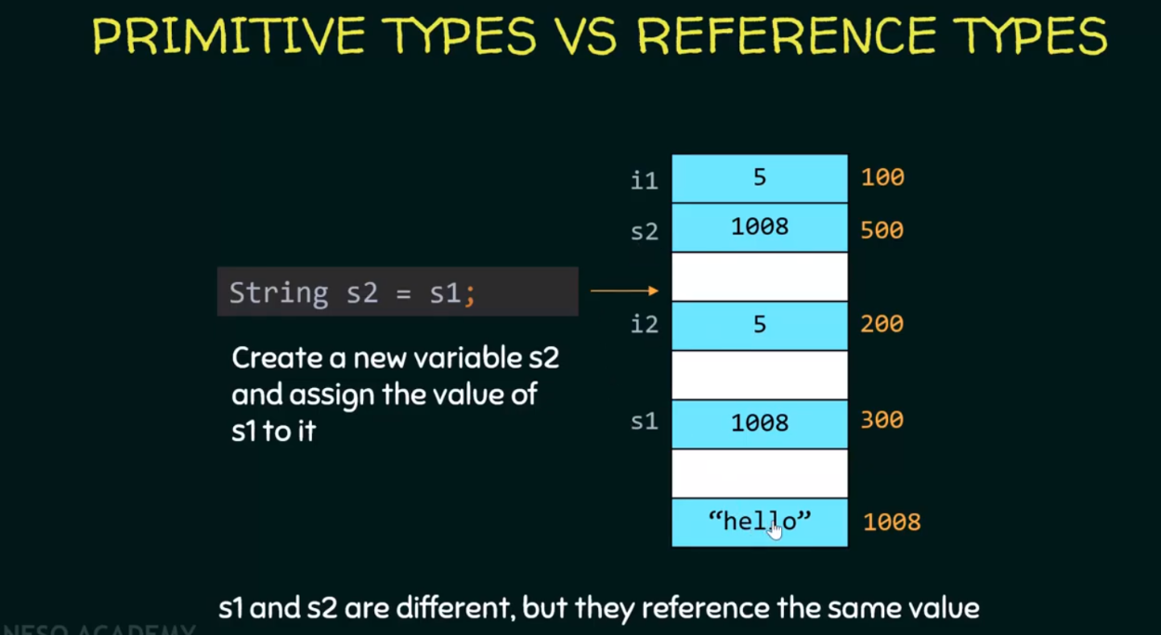

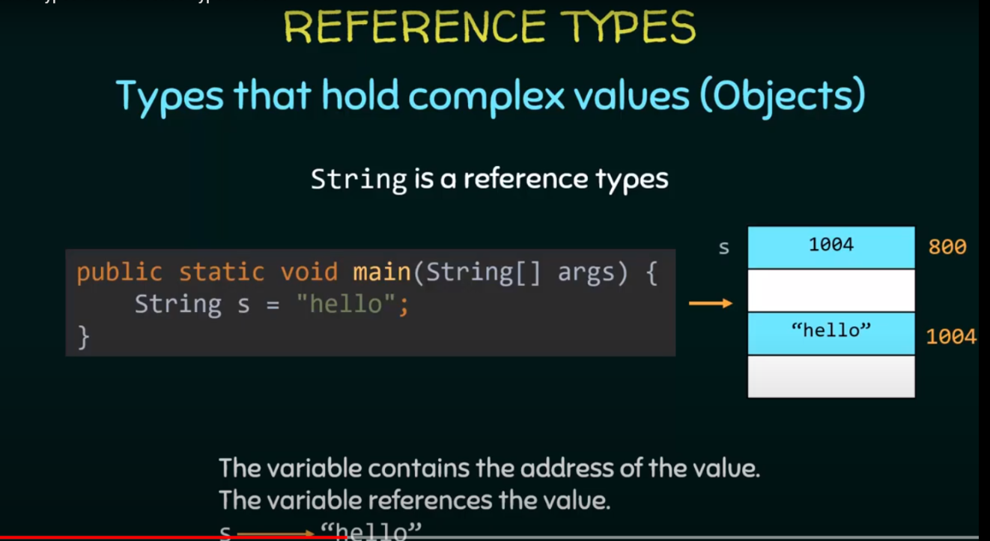

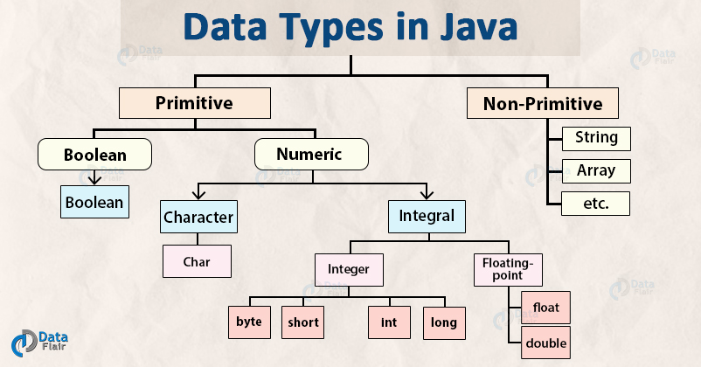

**What is Generic in java?**

* **It allow us to have only one type of object in java collection**

**Non generic arralist:** ArrayList list2 = **new** ArrayList();

**generic arralist :** ArrayList<String> list1 = **new** ArrayList<String>();

# Collections in Java

The **Collection in Java** is a framework that provides architecture to store and manipulate the group of objects.

Java Collections can achieve all the operations that you perform on a data such as searching, sorting, insertion, manipulation, and deletion.

**Collection :**

* **It** is a root level interface of the Java Collection Framework. Most of the classes in Java Collection Framework inherit from this interface. **List**, **Set** and **Queue** are main sub interfaces of this interface.
* **Collection is an interface**

**Collections** :

* It is an utility class in java.util package. It consists of only static methods which are used to operate on objects of type Collection.
* Java Collections can achieve all the operations that you perform on a data such as searching, sorting, insertion, manipulation, and deletion.
* For example, it has the method to find the maximum element in a collection, it has the method to sort the collection, it has the method to search for a particular element in a collection.
* **Collections is a class.**

A **Map**interface is also part of the **Collections**Framework, but it doesn't inherit **Collection**interface.

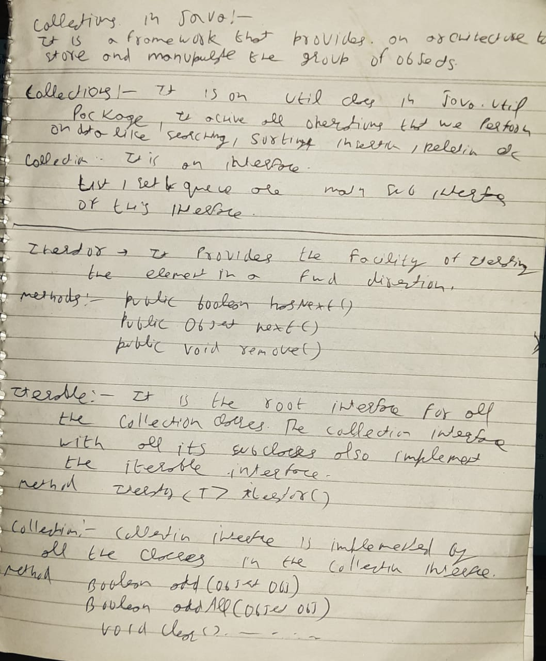

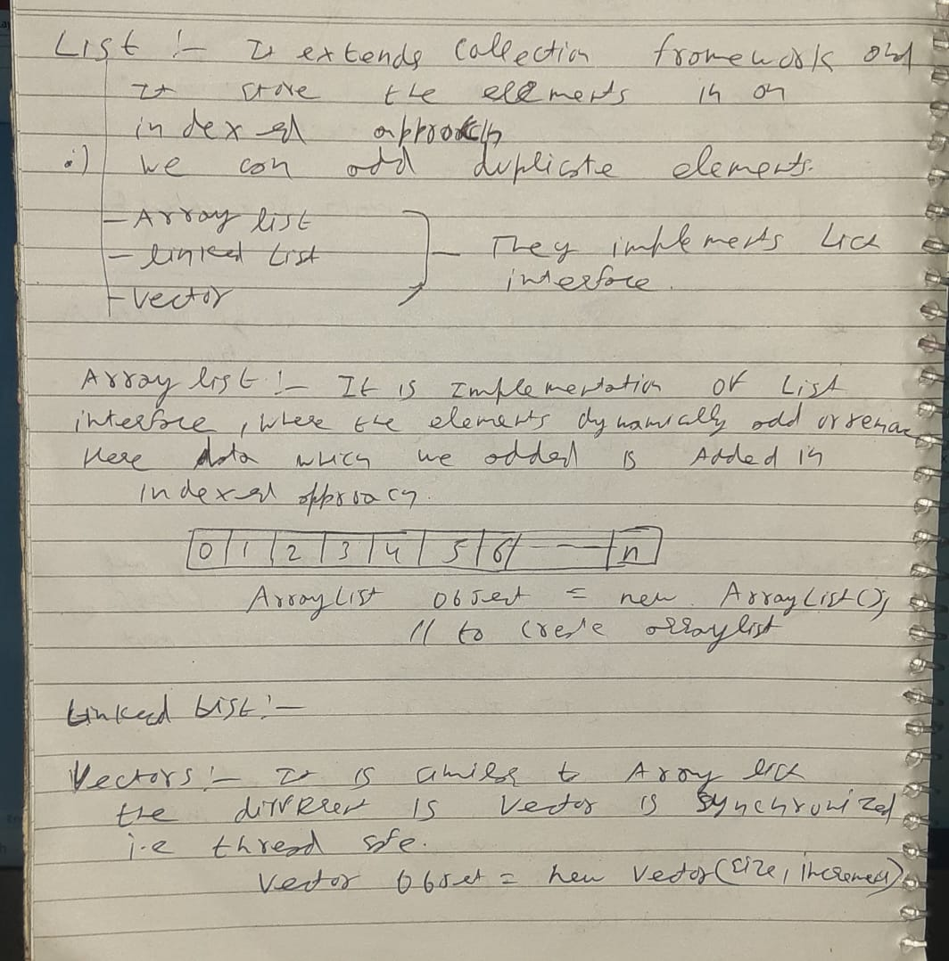

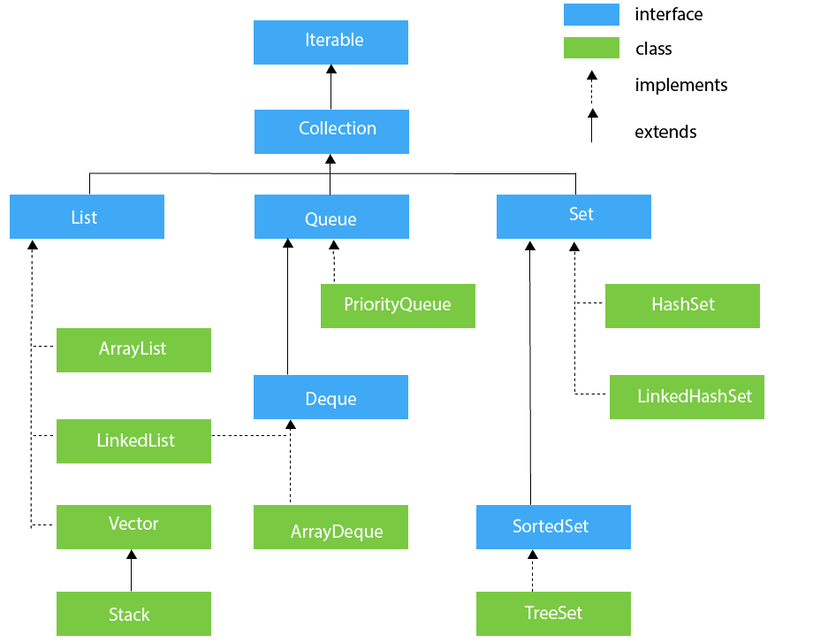

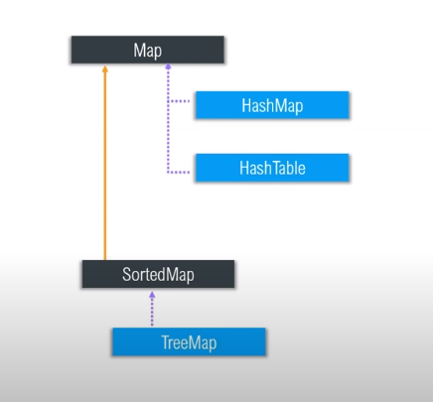

**What are all the Classes and Interfaces that are available in the collections?**

**Answer:** **Given below are the Classes and Interfaces that are available in Collections:**

**Interfaces:l**

* Collection
* List
* Set
* Map
* Sorted Set
* Sorted Map
* Queue

**Classes:**

* Lists:
* Array List
* Vector
* Linked List

**Sets:**

* Hash set
* Linked Hash Set
* Tree Set

**Maps:**

* Hash Map
* Hash Table
* TreeMap
* Linked Hashed Map

**Queue:**

* Priority Queue

**List :** it extends collection framework and it store elements in indexed approach

We can add duplicate elements in the list.

It is of three type:

1. **ArrayList**
2. **LinkedList**
3. **Vector**

**LIST MAINTAIN THE INSERTION ORDER**

* **ALL LIST ALLOW DUPLICATE INSERTION.**
* **LIST ALLOW NULL VALUES.**

**ArrayList :** ArrayList is the implementation of List Interface where the elements can be dynamically added or removed from the list. Also, the **size of the list is increased dynamically** if the elements are added more than the initial size.

* **It maintains the insertion order**

ArrayList object = new ArrayList ();

ArrayList arr = **new** ArrayList();

arr.add("tst");

arr.add("tst");

arr.add("tst");

arr.add("tst");

System.***out***.println(arr.size());

**OUTPUT: 4**

Where arraylist is **best choice is retrival operations**, it do it fast because it work with index numbers

Where arraylist is worst choice is when we want to insert and delete in middle because we required many shift(move) operations/ it start from 0th index

**Linked List**:

If we want to **insertion or deletion from middle**, then link list is the best choice

If our operation is retrieval/searching operation then linked list is worst choice because

Linked List is a sequence of links which contains items. Each link contains a connection to another link.

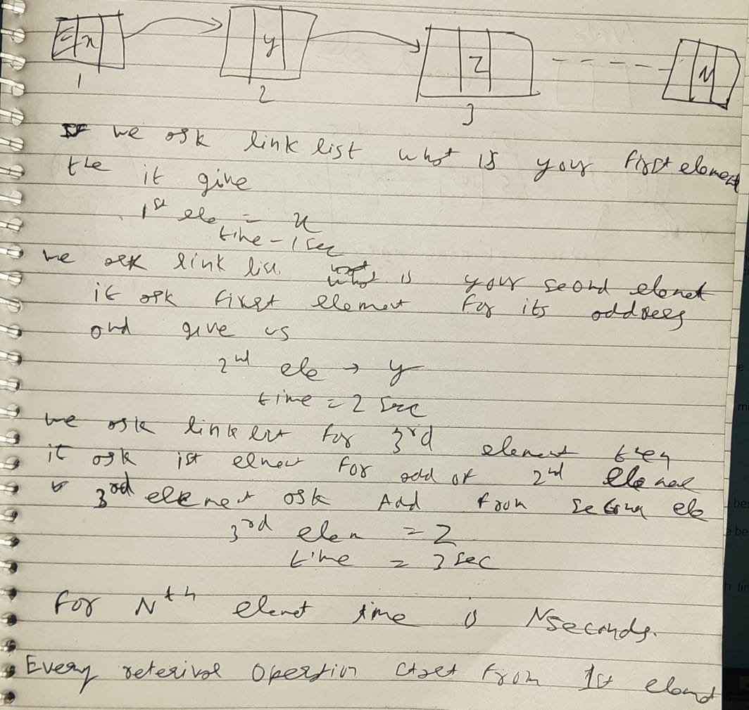

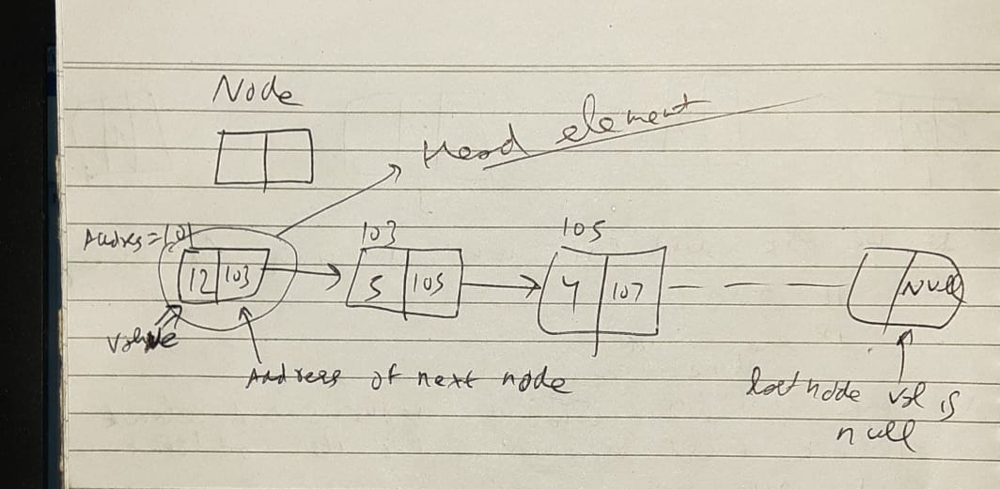

*Syntax*: Linkedlist object = new Linkedlist();

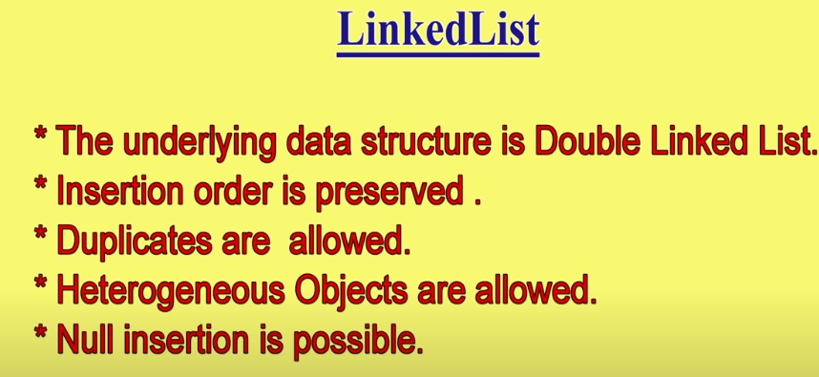

Java Linked List class uses two types of Linked list to store the elements:

* Singly Linked List
* Doubly Linked List

**Singly Linked List**: In a singly linked list each node in this list stores the data of the node and a pointer or reference to the next node in the list. Refer to the below image to get a better understanding of single Linked list.

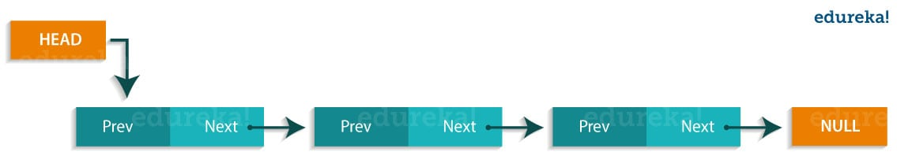

**Doubly Linked List**: In a doubly Linked list, it has two references, one to the next node and another to previous node. You can refer to the below image to get a better understanding of doubly linked list.

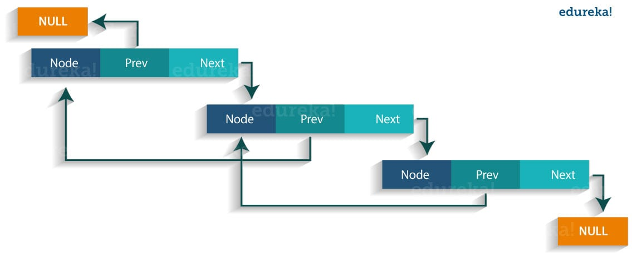

|  |  |
| --- | --- |
| **Method** | **Description** |
| boolean add( Object o) | It is used to append the specified element to the end of the vector. |
| boolean contains(Object o) | Returns true if this list contains the specified element. |
| void add (int index, Object element) | Inserts the element at the specified element in the vector. |
| void addFirst(Object o) | It is used to insert the given element at the beginning. |
| void addLast(Object o) | It is used to append the given element to the end. |
| int size() | It is used to return the number of elements in a list |
| boolean remove(Object o) | Removes the first occurrence of the specified element from this list. |
| int indexOf(Object element) | Returns the index of the first occurrence of the specified element in this list, or -1. |
| int lastIndexOf(Object element) | Returns the index of the last occurrence of the specified element in this list, or -1. |

Let us understand linked list with a programmatic example:

**import java.util.*;**

**public class LinkedlistExample{**

**public static void main(String args[]){**

**LinkedList<String> al=new LinkedList<String>();// creating linked list**

**al.add("Rachit"); // adding elements**

**al.add("Rahul");**

**al.add("Rajat");**

**Iterator<String> itr = al.iterator();**

**while(itr.hasNext()){**

**System.out.println(itr.next());**

**}**

**}**

**}**

The output of the above program would be:

Rachit

Rahul

Rajat

**ArrayList vs LinkedList :**

|  |  |
| --- | --- |
| **ArrayList** | **LinkedList** |
| 1) ArrayList internally uses a **dynamic array** to store the elements. | LinkedList internally uses a **doubly**  **linked list** to store the elements. |
| 2) Manipulation with ArrayList is **slow** because it internally uses an array. If any element is removed from the array, all the bits are shifted in memory. | Manipulation with LinkedList is **faster** than  ArrayList because it uses a doubly linked  list, so no bit shifting is required in memory. |
| 3) An ArrayList class can **act as a list** only because it implements List only. | LinkedList class can **act as a list and queue**  both because it implements List and Deque  interfaces. |
| 4) ArrayList is **better for storing and accessing** data.  5) Arraylist is of one type | LinkedList is **better for manipulating** data.  5) Linkedlist is of two types. |

**Vectors :**

* Vectors are similar to arraylist, where the elements of the vector object can be accessed via an index.
* Vector implements a dynamic array. Also, the vector is not limited to a specific size, it can shrink or grow automatically whenever required. It is similar to ArrayList.

But the **difference is** vector increase its size by 100% whereas **Arraylist** increase its size by 50% it conclude vectors waste too much memory as compare to arraylist.

**public static void main(String aargs[]) {**

**Vector v = new Vector();**

**System.*out*.println(v.capacity());**

**}**

**OUTPUT:**

10 //even for 1 extra element it allocate a space of 10

**But** vectors have few differences :

* **Vector is synchronized**, i.e. thread safe version of arraylist, which implies vectors are slow.
* Vector contains many legacy methods that are not part of the collections framework.
* vector increase its size by 100% whereas Arraylist increase its size by 50%.

**As vector introduce in JDK 1.0 and collection introduce in JDK1.2.**

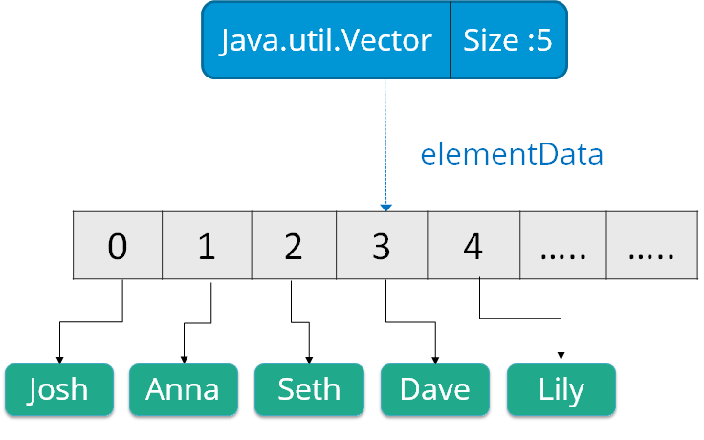

**Syntax**:

Vector object = new Vector(size,increment);

Below are some of the methods of the Vector class:

|  |  |
| --- | --- |
| **Method** | **Description** |
| boolean add(Object o) | Appends the specified element to the end of the list. |
| void clear() | Removes all of the elements from this list. |
| void add(int index, Object element) | Inserts the specified element at the specified position. |
| boolean remove(Object o) | Removes the first occurrence of the specified element from this list. |
| boolean contains(Object element) | Returns true if this list contains the specified element. |
| int indexOfObject (Object element) | Returns the index of the first occurrence of the specified element in the list, or -1. |
| int size() | Returns the number of elements in this list. |
| int lastIndexOf(Object o) | Return the index of the last occurrence of the specified element in the list, or -1 if the list does not contain any element. |

## ****What is Stack:****

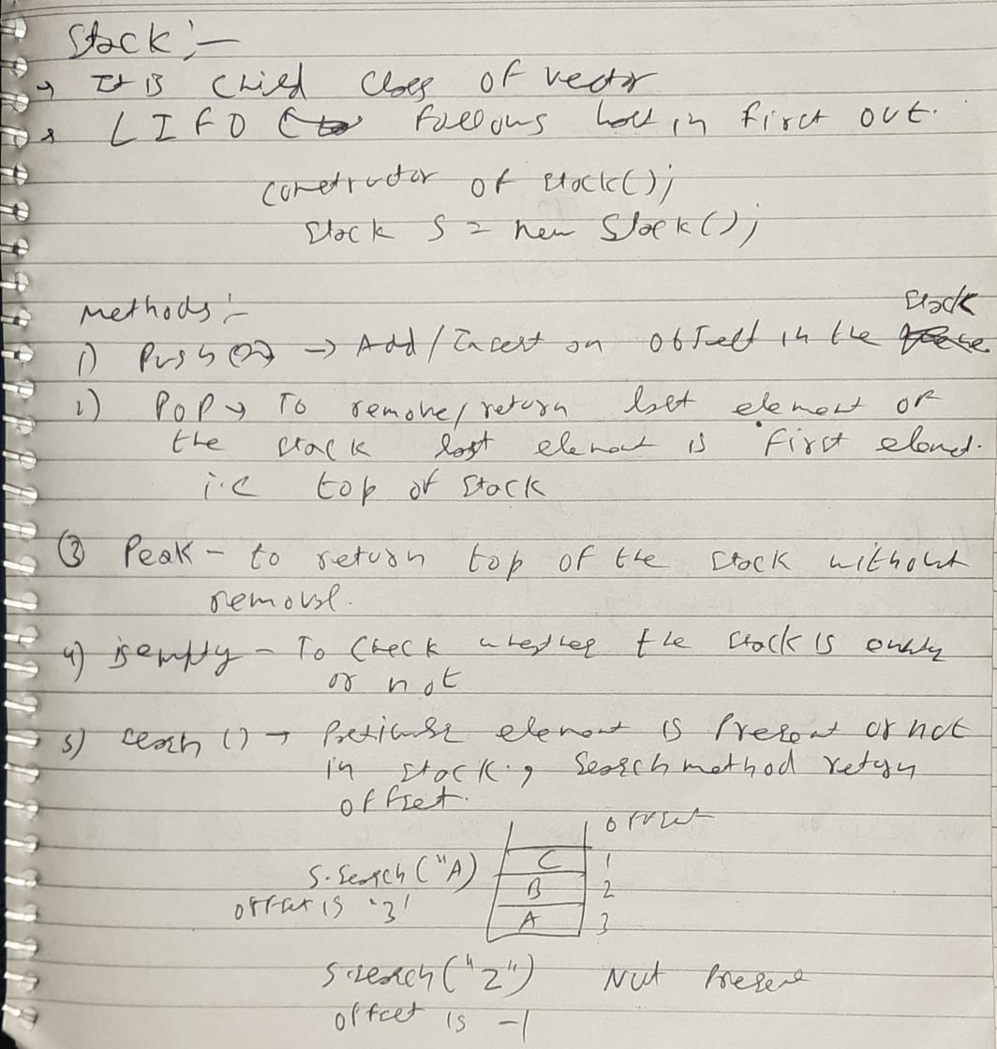

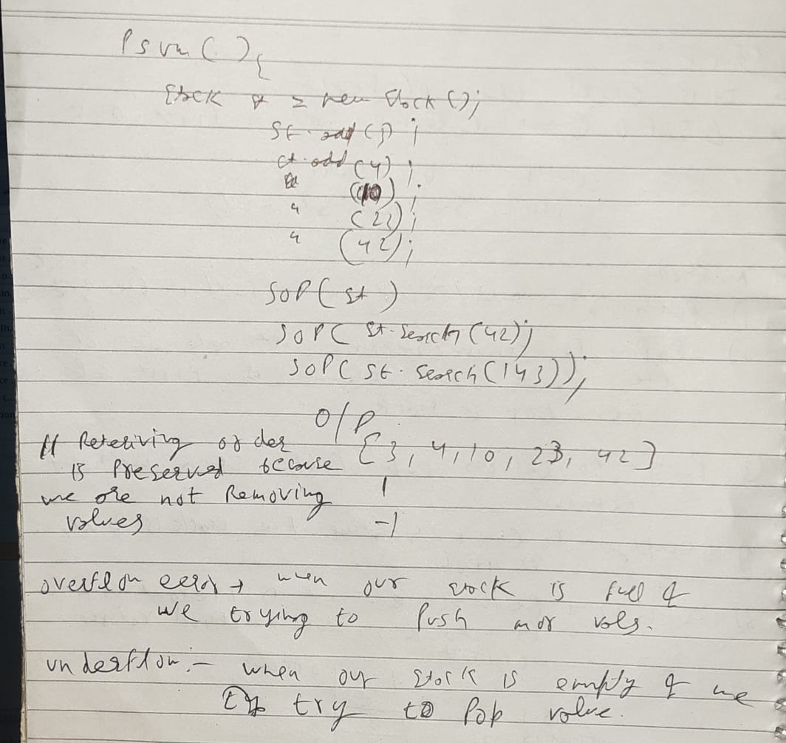

**public** **static** **void** main(String aargs[]) {

Stack st = **new** Stack();

st.push(12);

st.add(3);

st.add(34);

st.add(45);

st.add(23);

st.add(10);

st.add(23);

st.pop(); // remove the element from the top of the stack

System.***out***.println(st.empty()); // return true if stack is empty

System.***out***.println(st.peek()); // Looks at the object at the top of this stack without removing itfrom the

// stack

System.***out***.println(st);

System.***out***.println("size of stack is " + st.size());

System.***out***.println(st.search(10));

System.***out***.println(st.search(123));

}

**OUTPUT:**

false

10

[12, 3, 34, 45, 23, 10]

size of stack is 6

1

## -1

## ****Queue :****

Queue in Java follows a FIFO approach i.e. it orders the elements in First in First out manner. **Each basic method exists in two forms: one throws an exception if the operation fails, the other returns a special value**.

* **QUEUE NOT ALLOW INSERTION OF NULL ELEMENTS**  although some implementations, such as LinkedList , do not prohibit insertion of **null**
* **QUEUE ALLOW DUPLICATE VALUES**

enqueue(data) : insertion of data, we have to paas the data

dequeue(): Remove the element, we don’t pass a value but it returns a value

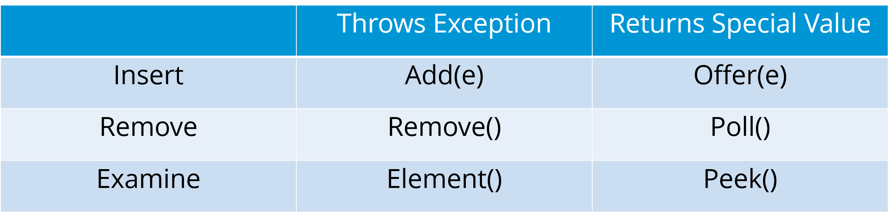

Few important characteristics of Queue are:

The Queue is used to insert elements at the end of the queue and removes from the beginning of the queue. It follows FIFO concept.

The Java Queue supports all methods of Collection interface including insertion, deletion etc.

[LinkedList](https://www.geeksforgeeks.org/linked-list-in-java/)(**Normal one see below code**), ArrayBlockingQueue and [PriorityQueue](https://www.geeksforgeeks.org/priority-queue-class-in-java-2/) are the most frequently used implementations.

If any null operation is performed on BlockingQueues, NullPointerException is thrown.

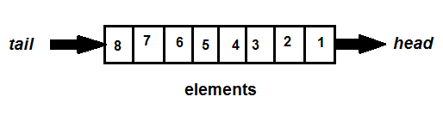

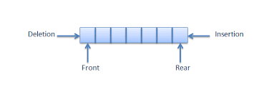

**public** **static** **void** main(String aargs[]) {

Queue<Integer> q = **new** LinkedList<>();

// Adds elements {0, 1, 2, 3, 4} to queue

**for** (**int** i = 2; i < 10; i++)

q.add(i);

// Display contents of the queue.

System.***out***.println("Elements of queue - " + q); // Display contents of the queue.

q.remove();

// This method removes and returns the head of the queue. **It throws NoSuchElementException** when the queue is empty.

q.poll();

// This method removes and returns the head of the queue. **It returns null** if the queue is empty.

System.***out***.println("Elements of queue - " + q);

q.remove(7); // remove element with data 7

System.***out***.println("Elements 7 of queue is removed - " + q);

System.***out***.println("peek of queue - " + q.peek()); // To view the head of queue

}

**OUTPUT:**

Elements of queue - [2, 3, 4, 5, 6, 7, 8, 9]

Elements of queue - [4, 5, 6, 7, 8, 9]

Elements 7 of queue is removed - [4, 5, 6, 8, 9]

peek of queue - 4

**Priority queue:** A Priority Queue is used when the objects are supposed to be processed based on the priority.

**PriorityQueue** doesn't allow **null values** to be **stored** in the **queue**.

**Priority queue** implements **AbstractQueue** interface. The elements of the **priority queue** are ordered according to their natural ordering or by a Comparator provided at queue construction time

**Comparator interface:** It help us to give priority at construction time(suppose we made two classes Student and children we can define priority of both according to our need)

The queue retrieval operations poll, remove, peek, and element access the element at the head of the queue.

In priority queue polling/removal of element take place on its priority basis

**public** **static** **void** main(String args[])

{

// Creating empty priority queue

PriorityQueue<Integer> pQueue = **new** PriorityQueue<Integer>();

//Queue<Integer> pQueue = new LinkedList<>();

// Adding items to the pQueue using add()

pQueue.add(2);

pQueue.add(10);

pQueue.add(3);

pQueue.add(9);

pQueue.add(2);

pQueue.add(14);

pQueue.add(12);

System.***out***.println(pQueue);

System.***out***.println(pQueue.poll());

System.***out***.println(pQueue.poll());

System.***out***.println(pQueue.poll());

System.***out***.println(pQueue.poll());

// Printing the top element of PriorityQueue

System.***out***.println(pQueue.peek());

// Printing the top element and removing it

// from the PriorityQueue container

System.***out***.println(pQueue.poll());

// Printing the top element again

System.***out***.println(pQueue.peek());//it shows the element jo next bahar nikalne vaala hai

}

**OUTPUT:**

[2, 2, 3, 10, 9, 14, 12] //element in pri queue is present in any order

2 // but at the time of removal it is ordered

2

3

9

10

10

12

**We can use Priority queue in that case suppose we have 10000 integers and we want to fetch top 5 smallest integers so, in that case we simply poll the 5 elements and we got top 5 smallest elements**

# ArrayBlockingQueue Class in Java:

# BlockingQueue doesn't accept null values and throw NullPointerException if you try to store null value

**ArrayBlockingQueue** class is a bounded blocking queue backed by an array. By bounded it means that the **size of the Queue is fixed**. Once created, the capacity cannot be changed. Attempts to **put an element into a full queue** will result in the **operation blocking**. Similarly attempts to take an **element from an empty queue** will also be **blocked**. Boundness of the ArrayBlockingQueue can be achieved initially by passing capacity as the parameter in the constructor of ArrayBlockingQueue. This queue orders elements **FIFO (first-in-first-out)**. It means that the head of this queue is the oldest element of the elements present in this queue. The tail of this queue is the newest element of the elements of this queue.

**public** **static** **void** main(String[] args)

{

// define capacity of ArrayBlockingQueue

**int** capacity = 15;

// create object of ArrayBlockingQueue

// using ArrayBlockingQueue(int initialCapacity) constructor

ArrayBlockingQueue<Integer> abq

= **new** ArrayBlockingQueue<Integer>(capacity);

// add numbers

abq.add(2);

abq.add(10);

abq.add(3);

abq.add(9);

abq.add(2);

abq.add(14);

abq.add(12);

// print queue

System.***out***.println("ArrayBlockingQueue:"

+ abq);

System.***out***.println(abq.poll());

System.***out***.println(abq.peek());

System.***out***.println("Remaining capacity is : "+abq.remainingCapacity());

}

**OUTPUT:**

ArrayBlockingQueue:[2, 10, 3, 9, 2, 14, 12]

2

10

Remaining capacity is : 9

# Deque interface in Java :

# 

# 

# 

Few important features of Deque are:

* It provides the support of resizable array and helps in restriction-free capacity, so to grow the array according to the usage.
* Array **deques prohibit** the use of **Null** elements and do not accept any such elements.
* Deque is **not thread-safe** or non- synchronization

Summarizing the methods, we get:.

# 

**public** **static** **void** main(String[] args) {

Deque<String> deque = **new** LinkedList<String>();

// We can add elements to the queue in various ways

deque.add("Element 1 (Tail.add)"); // add to tail

deque.addFirst("Element 2 (Head.addfirst)");

deque.addLast("Element 3 (Tail.addlast)");

deque.push("Element 4 (Head.push)"); // add to head

deque.offer("Element 5 (Tail.offer)");

deque.offerFirst("Element 6 (Head.offerfirst)");

deque.offerLast("Element 7 (Tail.offerlast)");

Iterator iterator = deque.iterator();

**while** (iterator.hasNext()) {

System.***out***.println(iterator.next());

}

System.***out***.println("##############################################");

// Reverse order iterator

Iterator reverse = deque.descendingIterator();

System.***out***.println("Reverse Iterator");

**while** (reverse.hasNext())

System.***out***.println("\t" + reverse.next());

// Peek returns the head, without deleting

// it from the deque

System.***out***.println("Peek " + deque.peek());

System.***out***.println("After peek: " + deque);

// Pop returns the head, and removes it from

// the deque

System.***out***.println("Pop " + deque.pop());

System.***out***.println("After pop: " + deque);

// We can check if a specific element exists

// in the deque

System.***out***.println("Contains element 3: " + deque.contains("Element 3 (Tail)"));

// We can remove the first / last element.

deque.removeFirst(); //deque.remove(); removes the first element

deque.removeLast();

System.***out***.println("Deque after removing " +

"first and last: " + deque);

}

# OUTPUT:

Element 6 (Head.offerfirst)

Element 4 (Head.push)

Element 2 (Head.addfirst)

Element 1 (Tail.add)

Element 3 (Tail.addlast)

Element 5 (Tail.offer)

Element 7 (Tail.offerlast)

##############################################

Reverse Iterator

Element 7 (Tail.offerlast)

Element 5 (Tail.offer)

Element 3 (Tail.addlast)

Element 1 (Tail.add)

Element 2 (Head.addfirst)

Element 4 (Head.push)

Element 6 (Head.offerfirst)

Peek Element 6 (Head.offerfirst)

After peek: [Element 6 (Head.offerfirst), Element 4 (Head.push), Element 2 (Head.addfirst), Element 1 (Tail.add), Element 3 (Tail.addlast), Element 5 (Tail.offer), Element 7 (Tail.offerlast)]

Pop Element 6 (Head.offerfirst)

After pop: [Element 4 (Head.push), Element 2 (Head.addfirst), Element 1 (Tail.add), Element 3 (Tail.addlast), Element 5 (Tail.offer), Element 7 (Tail.offerlast)]

Contains element 3: false

Deque after removing first and last: [Element 1 (Tail.add), Element 3 (Tail.addlast), Element 5 (Tail.offer), Element 7 (Tail.offerlast)]

# SET in JAVA:

# ONLY treeset ALLOW NOT NULL

# DUPLICATE VALUES NOT ALLOW IN SET

# Set cares about uniqueness. It doesn’t allow duplications. Here “equals ( )” method is used to determine whether two objects are identical or not.

**public** **static** **void** main(String[] args) {

HashSet<String> hset = **new** HashSet<String>();

hset.add("jack");

hset.add("sam");

hset.add("john");

hset.add("jimmy");

hset.add("nick");

hset.add("drew");

hset.add("drew");

hset.add("drew");

hset.add("drew");

**for** (String abs : hset) {

System.***out***.println(abs);

}

# }

# OUTPUT:

nick

john

jimmy

jack

sam

drew //return duplicate only once

# 

**public** **static** **void** main(String[] args) {

LinkedHashSet<String> lhs = **new** LinkedHashSet<String>();

lhs.add("test");

lhs.add("rest");

lhs.add("api");

lhs.add("selemium");

lhs.add("appium");

**for**(String abc : lhs) {

System.***out***.println(abc);

}

# }

# OUTPUT:

test

rest

api

selemium

appium

**public** **static** **void** main(String[] args) {

TreeSet<Integer> teset = **new** TreeSet<Integer>();

teset.add(4);

teset.add(56);

teset.add(2912);

teset.add(93);

teset.add(34);

teset.add(53);

teset.add(34);

**for**(Integer abc : teset) {

System.***out***.println(abc);

}

System.***out***.println("@@@@@@@@@@@@@@@@@@@@@@@@@@@@@@@@@@@@@@@@@@");

Iterator it = teset.descendingIterator();

**while**(it.hasNext()) {

System.***out***.println(it.next());

}

# }

# OUTPUT:

4

34

53

56

93

2912

@@@@@@@@@@@@@@@@@@@@@@@@@@@@@@@@@@@@@@@@@@

2912

93

56

53

34

4

**Difference between HashSet and TreeSet.**

**Answer:** **Difference between HashSet and TreeSet can be seen below:**

| **HashSet** | **TreeSet** |
| --- | --- |
| Inserted elements are in random order | Maintains the elements in the sorted order |
| Can able to store null objects  hset.add(**null**); | Couldn’t store null objects  teset.add(**null**); |
| Performance is fast | Performance is slow(it take time to sort the elements) |

**Map in java?**

**DUPLICATE ELEMENTS NOT ALLOWED**

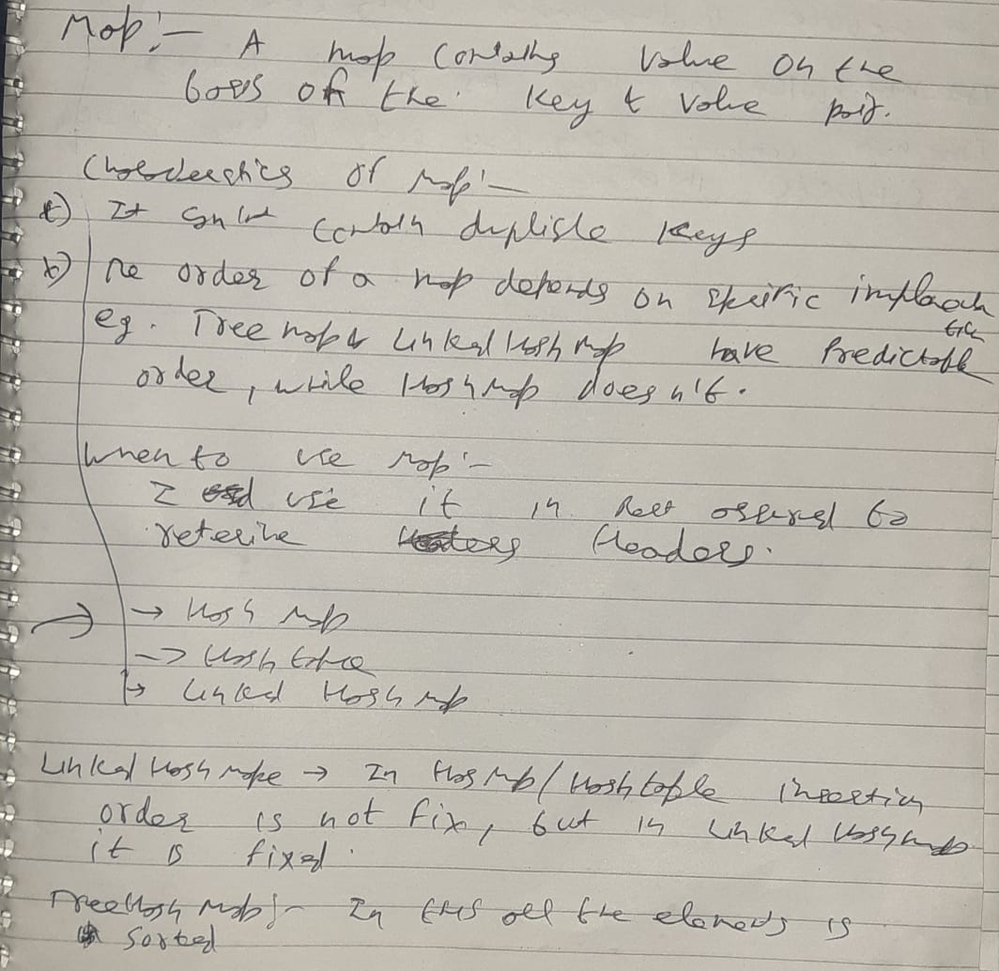

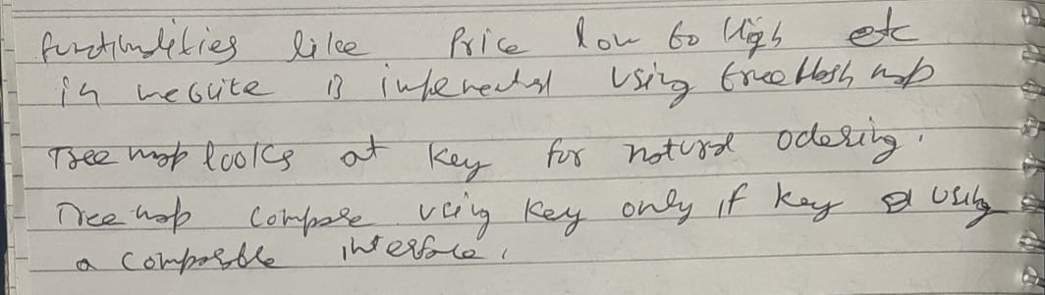

**Difference between HashMap and HashTable.**

| **HashMap** | **HashTable** |
| --- | --- |
| Methods are not synchronized i.e Not  thread safe | Key methods are synchronized i.e  thread safe |
| Introduce in JDK 1.2 | Introduce since java is introduce |
| Performance is high than HashTable | Performance is slow |
| Allows one null key and multiple null values  hmap.put(**null**, **null**);  hmap.put(75, **null**);  hmap.put(98, **null**); | Doesn’t allow anything that is null  ht.put(**null**, **null**);Exception in thread "main" java.lang.NullPointerException  at java.util.Hashtable.put(Unknown Source)  at collection.hashtable.main(hashtable.java:19) |

**Difference between ArrayList and HashSet in Java?**

| **ArrayList** | **HashSet** |
| --- | --- |
| ArrayList implements List interface | HashSet implements Set interface |
| ArrayList allows duplicates | HashSet doesn’t allow duplicates |
| ArrayList is an ordered collection and maintains insertion order of elements | HashSet is an unordered collection and doesn’t maintain insertion order |
| ArrayList is backed by an Array | HashSet is backed by an HashMap instance |
| ArrayList is an index based | HashSet is object based |
| In ArrayList, we can retrive object by calling get() method or remove object by calling remove() method | In HashSet, we can’t achieve get() method |
| To put an object into array we need to specify the index.  name[1] = “book” | No index required. Store element using hashing technique  name.add(“book”) |

# 

| **ABSTRACT CLASS** | **INTERFACE** |
| --- | --- |
| To declare Abstract class we have to use abstract keyword | To declare Interface we have to use interface keyword |
| In an Abstract class keyword abstract is mandatory to declare a method as an abstract | In an Interface keyword abstract is optional to declare a method as an abstract. Compiler treats all the methods as abstract by default |
| An abstract class contains both abstract methods and concrete methods(method with body) | An interface can have only abstract methods |
| An abstract class provides partial abstraction | An interface provides fully abstraction |
| An abstract class can have public and protected abstract methods | An interface can have only public abstract methods |
| An abstract class can have static, final or static final variables with any access modifiers | An interface can have only public static final variables |
| An abstract class can extend one class or one abstract class | An interface can extend any number of interfaces |
| Abstract class doesn't support multiple inheritance | Interface supports multiple inheritance |

**Can we able to create constructor for Abstract class ?**

**YES**

**abstract** **class** A {

A() {

System.***out***.println("print me");

}

}

**public** **class** linkedlist **extends** A {

linkedlist() {

**super**();

}

**public** **static** **void** main(String args[]) {

linkedlist ob = **new** linkedlist();

}

}

can a abstract class extend another abstract class

yes

**Can we able to create constructor for Interface ?**

**NO, it will give compile time error**

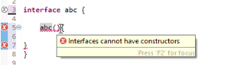

**Can we able to create object for Interface ?**

No, compile time error

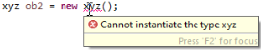

**Can we able to create object for abstract class ?**

No, compile time error

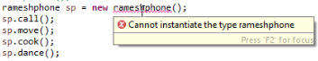

**What is meant by Ordered and Sorted in collections?**

**Answer:**

**Ordered:**It means the values that are stored in a collection is based on the values that are added to the collection. So we can iterate the values from the collection in a specific order.

**Sorted:**Sorting mechanisms can be applied internally or externally so that the group of objects sorted in a particular collection is based on the properties of the objects.

# Exceptions in Java

**What is an Exception?**

An exception is an unwanted or unexpected event, which occurs during the execution of a program i.e at run time, that disrupts the normal flow of the program’s instructions.

Or

**We can handle the exceptions.**

### Error

Error is irrecoverable e.g. OutOfMemoryError, VirtualMachineError, AssertionError etc.

**Or**

**we can’t handle error at run time**

**For ex: Our JVM is not working properly or our ram goes out of memory**

## What is Exception Handling

Exception Handling is a mechanism to handle runtime errors such as ClassNotFoundException, IOException, SQL Exception, Remote Exception, etc.

### Advantage of Exception Handling

### The core advantage of exception handling is **to maintain the normal flow of the application**.

1. statement 1;
2. statement 2;
3. statement 3;
4. statement 4;
5. statement 5;//exception occurs
6. statement 6;
7. statement 7;
8. statement 8;
9. statement 9;
10. statement 10;

Suppose there are 10 statements in your program and there occurs an exception at statement 5, the rest of the code will not be executed i.e. statement 6 to 10 will not be executed. If we perform exception handling, the rest of the statement will be executed. That is why we use exception handling in [Java](https://www.javatpoint.com/java-tutorial).

**Throwable:** The Throwable class is the root class of Java Exception hierarchy which is inherited by two subclasses: Exception and Error. A hierarchy of Java Exception classes are given below:

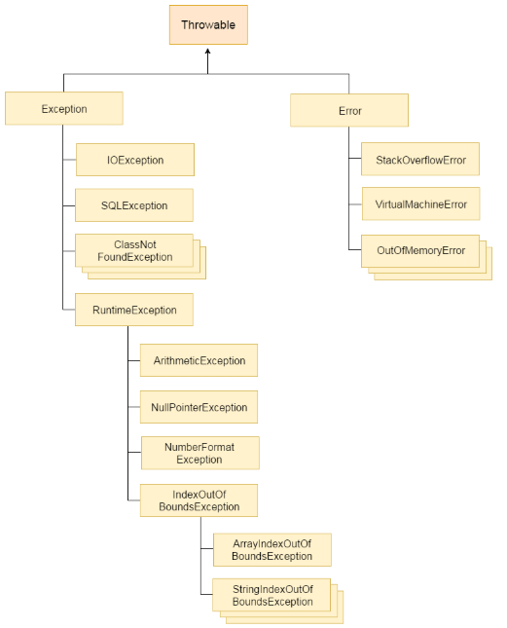

## Difference between Checked and Unchecked Exceptions

### 1) Checked Exception (Thread sleep because it check for exception at compile time and give us suggestion to add trycatch or add throws)

The classes which directly inherit Throwable class except RuntimeException and Error are known as checked exceptions e.g. IOException, SQLException etc. Checked exceptions are checked at compile-time but it occur at runtime as all exceptons are occur at runtime.

**public** **static** **void** main(String args[]) {

**try** {

} **catch** (FileNotFoundException e) {

System.***out***.println("checked exception file not found : "+e); }

}

### 2) Unchecked Exception:

The classes which inherit Runtime Exception are known as unchecked exceptions e.g. ArithmeticException, NullPointerException, ArrayIndexOutOfBoundsException etc. Unchecked exceptions are not checked at compile-time/ compilers are not capable to check unchecked exceptions, but they are checked at runtime.

**public** **static** **void** main(String[] args) {

**try**

{

**int** arr[]= {1,3,5,7};

System.***out***.println(arr[10]); //may throw exception

}

// handling the array exception

**catch**(ArrayIndexOutOfBoundsException e)

{

System.***out***.println(e);

}

System.***out***.println("rest of the code");

}

// arithmetic exception is unchecked exception

//null pointer exception is unchecked exception

String name= **null**;

System.out.println(name.length());

|  |  |  |  |
| --- | --- | --- | --- |
| **Keyword** | | **Description** | |
| try | The "try" keyword is used to specify a block where we should place  exception code. | |
| catch | Java catch block is used to handle the Exception by declaring the type of  Exception . we can't use catch block alone. | |
| finally | The "finally" block is used to execute the important code of the program.  It is executed whether an exception is handled or not. | |
| throw | The "throw" keyword is used to throw an exception. | |
| throws (thread.sleep()) | The "throws" keyword is used to declare exceptions. It doesn't throw an  exception. It specifies that there may occur an exception in the method.  It is always used with method signature. | |

## Java Multi-catch block

**public** **static** **void** main(String[] args) {

**try**{

**int** a[]=**new** **int**[5];

a[5]=30/0;

}

**catch**(ArithmeticException e)

{

System.***out***.println("Arithmetic Exception occurs");

}

**catch**(ArrayIndexOutOfBoundsException e)

{

System.***out***.println("ArrayIndexOutOfBounds Exception occurs");

}

**catch**(Exception e)

{

System.***out***.println("Parent Exception occurs");

}

System.***out***.println("rest of the code");

# }

# Java Nested try block

The try block within a try block is known as nested try block in java.

### Why use nested try block

Sometimes a situation may arise where a part of a block may cause one error and the entire block itself may cause another error.

**public** **static** **void** main(String args[]) {

**try** {

**try** {

System.***out***.println("going to divide");

**int** b = 39 / 0;

} **catch** (ArithmeticException e) {

System.***out***.println(e);

}

**try** {

**int** a[] = **new** **int**[5];

a[5] = 4;

} **catch** (ArrayIndexOutOfBoundsException e) {

System.***out***.println(e);

}

System.***out***.println("other statement");

} **catch** (Exception e) {

System.***out***.println("handeled");

}

System.***out***.println("normal flow..");

}

# Java finally block

**Java finally block** is a block that is used to execute important code such as closing connection, closing file etc.

Java finally block is always executed whether exception is handled or not.

**public** **static** **void** main(String args[]){

**try**{

**int** data=25/5;

System.***out***.println(data);

}

**catch**(NullPointerException e){System.***out***.println(e);}

**finally**{System.***out***.println("finally block is always executed");}

System.***out***.println("rest of the code...");

}

**OUTPUT:**

5

finally block is always executed

rest of the code...

# Java Exception propagation

|  |
| --- |
| An exception is first thrown from the top of the stack and if it is not caught, it drops down the call  stack to the previous method, If not caught there, the exception again drops down to the previous  method, and so on until they are caught or until they reach the very bottom of the call stack.This is  called exception propagation.  **int** data = 50 / 0;  }  **void** n() {  m();  }  **void** p() {  **try** {  n();  } **catch** (Exception e) {  System.***out***.println("exception handled");  }  }  **public** **static** **void** main(String args[]) {  exceptionpropogation obj = **new** exceptionpropogation();  obj.p();  System.***out***.println("normal flow...");  }  **OUTPUT :**  exception handled  normal flow... |

# exception propagation

In the above example exception occurs in m() method where it is not handled,so it is propagated to previous n() method where it is not handled, again it is propagated to p() method where exception is handled.

Exception can be handled in any method in call stack either in main() method,p() method,n() method or m() method.

# *NOTE:*

# *Checked exceptions are not propagated*

**ways to print exception ?**

we have three ways to print exception

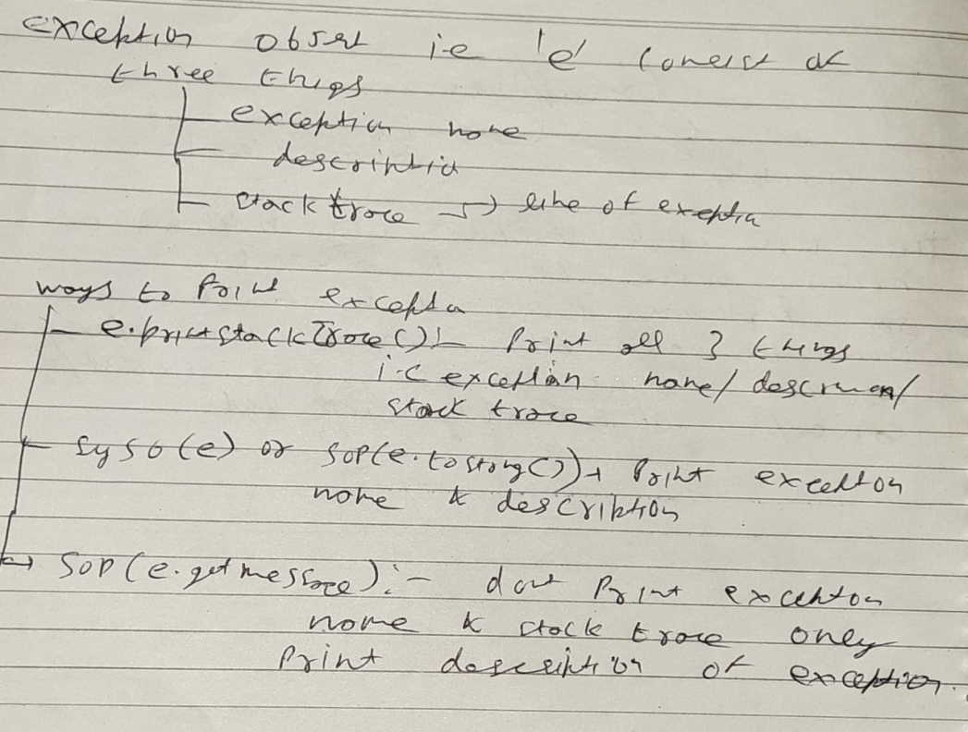

**e.printStackTrace();**

# it give us all info about exception like name of exception, description of exception, kis line k andar exception hai, kis method me exception hai

**final vs finally vs finalize**

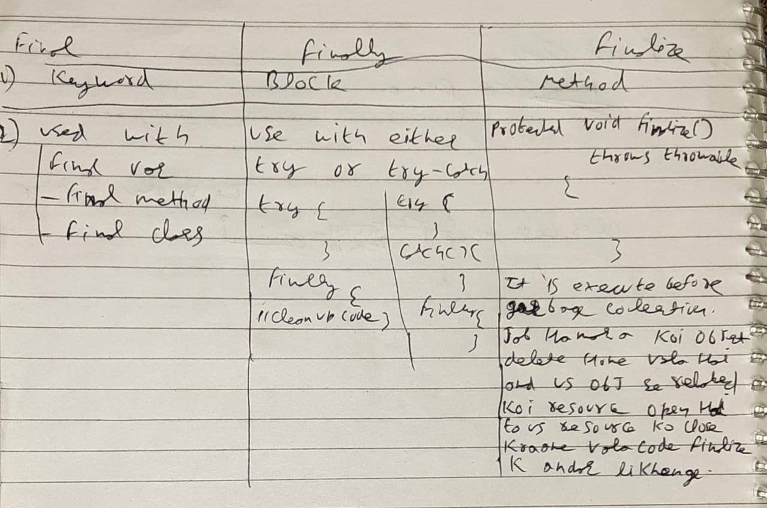

**Garbage collection in java/Finalize keyword in java:**

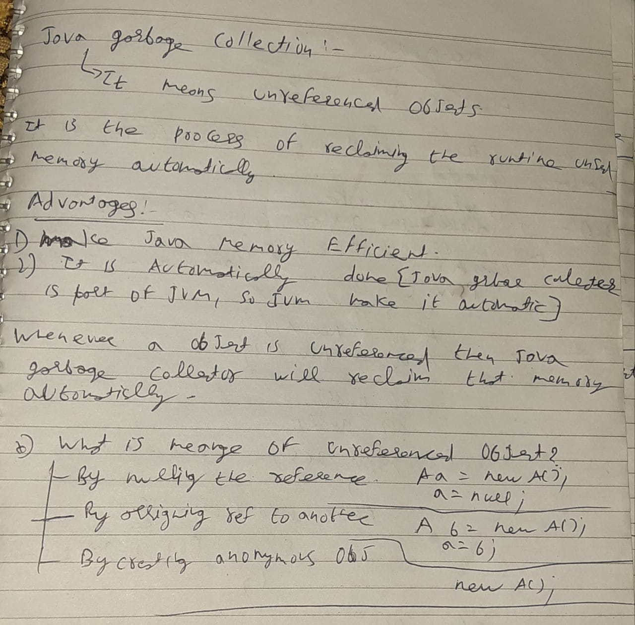

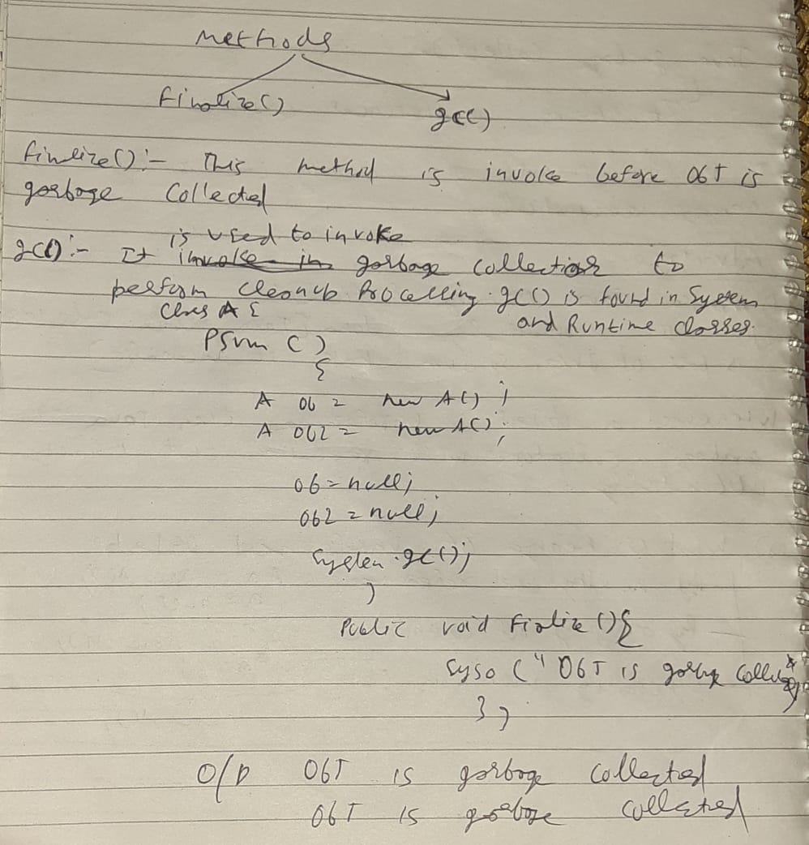

## Java throw keyword

The Java throw keyword is used to explicitly throw an exception.

We can throw either checked or uncheked exception in java by throw keyword. The throw keyword is mainly used to throw custom exception.

**Syntax:**

**throw** **new** IOException("sorry device error);

**public** **class** throwkeyword {

**void** test(**int** age) {

**if** (age < 18) {

**throw** **new** ArithmeticException("Age must be greater than 18");

} **else** {

System.***out***.println("Valid age");

}

}

**public** **static** **void** main(String args[]) {

throwkeyword th = **new** throwkeyword();

**try** {

th.test(10);

}

**catch** (ArithmeticException e) {

System.***out***.println(e);

}

}

}

**OUTPUT:**

java.lang.ArithmeticException: Age must be greater than 18

## Java throws keyword

It gives information to the programmer that there may occur an exception.

Only checked exception can be handle using throws

**class** test {

**void** read() **throws** FileNotFoundException { // here we only throw exception not handling it if any other class call this method then that class need to handle exception

FileInputStream fis = **new** FileInputStream("Downloads\\Ashish_Singh");

}

**void** write() **throws** FileNotFoundException {

FileOutputStream fos = **new** FileOutputStream("Downloads\\Ashish_Singh");

}

}

**public** **class** throwsexcp {

**public** **static** **void** main(String args[]) **throws** FileNotFoundException {

test t = **new** test();

**try** {

t.read();

} **catch** (FileNotFoundException e) {

e.printStackTrace();

System.***out***.println("success"); ////normally terminate print the hello

}

t.write(); //abnormally terminate don't print the hello

System.***out***.println("success");

}

}

Throws can’t handle the exception it only indicates that this line of code throw that type of exception.

if we call that method which throw exception in another class than we need to handle the exception.

[**Java Throw vs Throws**](https://www.javatpoint.com/difference-between-throw-and-throws-in-java)

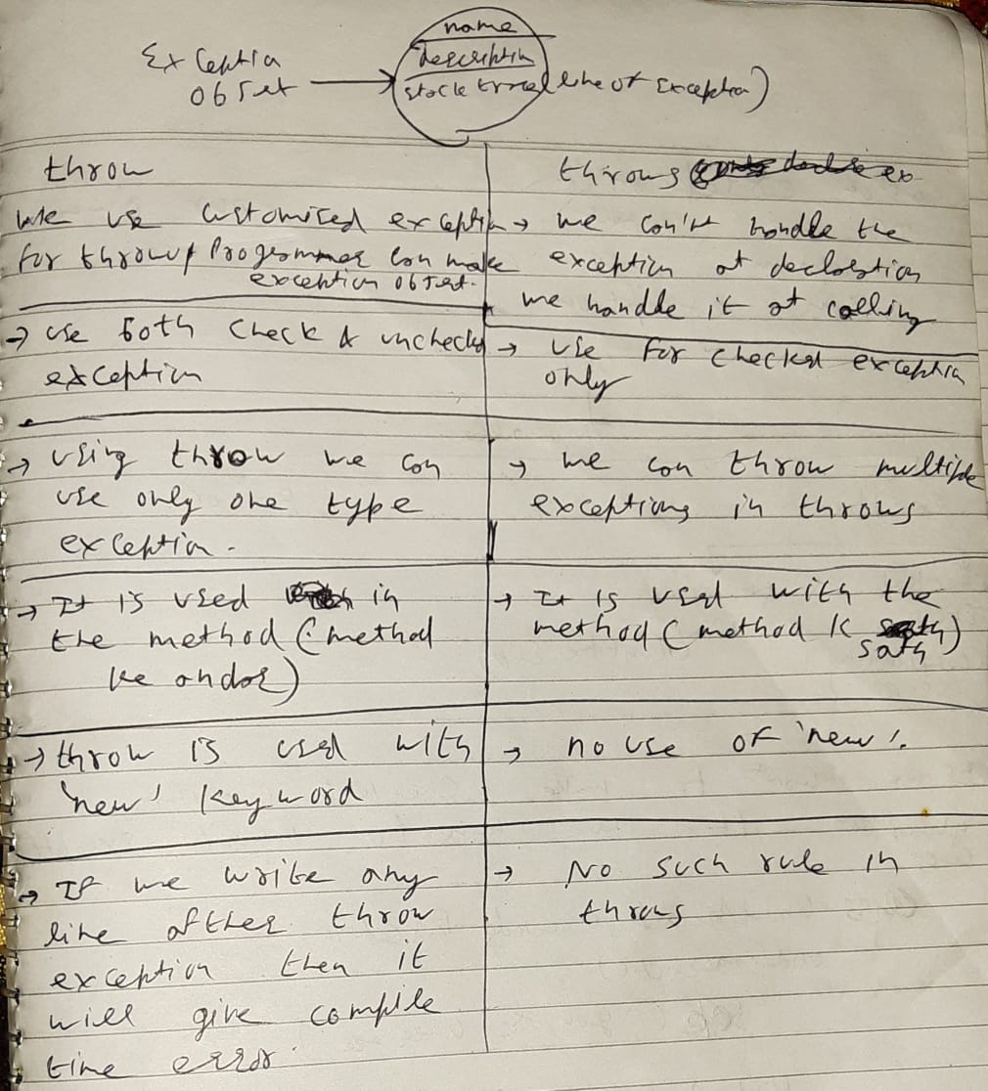

# Java Custom Exception:

# 

# 

# Final keyword in java

# 

# 

# 

# We can use final with variable method and class

# We use it with variable when we want our variable value won’t change it remain constant

# We use it with method when we want our method won’t override

We use it with class when we want our class won’t inherit

**This keyword in java ?**

‘this’ is a reference variable that refers to the current class object.

this.x = x; //here ‘this’ represents the current class instance variable

**package** QA;

**package** QA;

**public** **class** thiskeyword {

**public** **static** **void** main(String args[]) {

thiskey obj = **new** thiskey();

obj.put(10);

obj.show();

}

}

**class** thiskey {

**int** x; //instance variable

**void** put(**int** x) {// here x is local variable

**this**.x = x; // if we remove this from here then the output is 0 , because in x = x both x represents the local variables by default value of this var is 0

}

**void** show() {

System.***out***.println("Value of x is : " + x);

}

}

**Super keyword in java ?**

Super keyword is a reference variable which is used to refer immediate parent class object

**public** **static** **void** main(String args[]) {

child ob = **new** child();

ob.set(30);

}

}

**class** parent {

**int** a = 10;

}

**class** child **extends** parent {

**int** a = 20; // instance variable

**void** set(**int** a) {

System.***out***.println(a);

System.***out***.println(**this**.a); //this refer to current class instance variable

System.***out***.println(**super**.a); //this refer to current class instance variable

}

Using constructor :

/* superclass Person */

**class** Person

{

Person()

{

System.***out***.println("Person class Constructor");

}

}

/* subclass Student extending the Person class */

**class** Student **extends** Person

{

Student()

{

// invoke or call parent class constructor

**super**();

System.***out***.println("Student class Constructor");

}

}

/* Driver program to test*/

**class** superconstkey

{

**public** **static** **void** main(String[] args)

{

Student s = **new** Student();

}

**Is null a keyword in java?**

In **Java**, **null** is a reserved word (**keyword**) for literal values. It seems like a **keyword**, but actually, it is a literal similar to true and false. The reserved word **null** is case sensitive and we cannot write **null** as **Null** or **NULL**, the compiler will not recognize them and give an error(Compile time error).

**Declaration of float and ‘1.0’ is possible?**

No, 1.0 is taken as double

double db=1.0;

to declare float

**float** f = 1.11f;

to declare double

**double** f2 = 1.11d; **// changing to double**

double db=1.0;

**change double to int?**

**int** IntValue = (**int**) f2;

**Static block in java?**

Java supports a special block, called static block (also called static clause) which can be used for static initializations of a class. This code inside static block is executed only once: the first time the class is loaded into memory.

// filename: Main.java

class Test {

static int i;

int j;

// start of static block

static {

i = 10;

System.out.println("static block called ");

}

// end of static block

}

class Main {

public static void main(String args[]) {

// Although we don't have an object of Test, static block is

// called because i is being accessed in following statement.

System.out.println(Test.i);

}

}

# The Initializer Block in Java

Initializer block contains the code that is always executed whenever an instance is created. It is used to declare/initialize the common part of various constructors of a class. For example,

**import** java.io.*;

**public** **class** GFG { // Initializer block starts..

{

// This code is executed before every constructor.

System.***out***.println("Common part of constructors invoked !!");

}

// Initializer block ends

**public** GFG() {

System.***out***.println("Default Constructor invoked");

}

**public** GFG(**int** x) {

System.***out***.println("Parametrized constructor invoked");

}

**public** **static** **void** main(String arr[]) {

GFG obj1, obj2;

obj1 = **new** GFG();

obj2 = **new** GFG(0);

}

}

**Output:**

Common part of constructors invoked!!

Default Constructor invoked

Common part of constructors invoked!!

Parametrized constructor invoked

**Hetrogenous objects ?**

**It contains different types of objects**

A heterogeneous collection could be an Object[] array, or List<Object> list.

**Homogenous objects ?**

**It contains same type of objects**

List<Integer>

**clonable interface?**

**It is the one concept of object copying. We can copy objects by 3 ways.**

* 1. **Shallow copy**
  2. **Deep copy**
  3. **Cloning**

1. **Shallow copy**

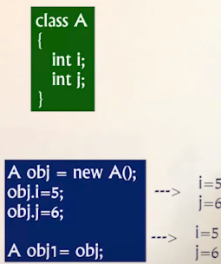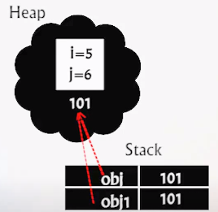

**One object is referring to two reference**

**If we change the value of obj1 it will refelect to obj**

1. **Deep copy**

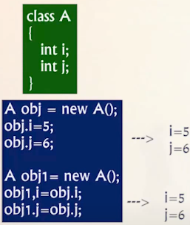 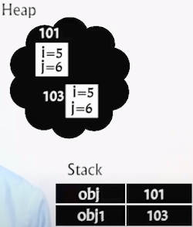

1. **Cloning**

Simply use obj.clone(); to copy the objects

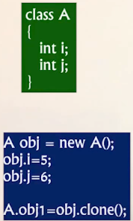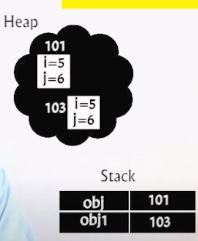

**Serializable , random access interface**

**Heap memory?**

**String pool**

**Create two string using new method(it is created in heap memory)**

**Single try for multiple catch?**

Why we need wrapper classes instead of

Primitive type into object type?

String program[reverse string, print alternate chars of string]

Webdriver driver = new firefoxdriver();